# Conservation benefits of a marine protected area network accrue across multiple coastal ecosystems

Joshua G. Smith1,2*, Cori Lopazanski3, Christopher M. Free3,4, Julien Brun18, Clarissa Anderson5, Mark H. Carr6, Joachim Claudet7, Jenifer E. Dugan4, Jacob G. Eurich8,1, Tessa B. Francis9, David A. Gill10, Scott L. Hamilton11, Kristin Kaschner12, David Mouillot13,14, Peter T. Raimondi6, Richard M. Starr11, Shelby L. Ziegler15, Daniel Malone6, Michelle L. Marraffini4, Avery Parsons-Field4, Barbara Spiecker16, Mallarie Yeager17, Kerry J. Nickols18,19, Jennifer E. Caselle4

1 National Center for Ecological Analysis and Synthesis, University of California, Santa Barbara, Santa Barbara, CA, USA

2 Conservation and Science Division, Monterey Bay Aquarium, CA, USA

3 Bren School of Environmental Science and Management, University of California, Santa Barbara, Santa Barbara, CA, USA  
4 Marine Science Institute, University of California, Santa Barbara, Santa Barbara, CA, USA

5 Scripps Institution of Oceanography/Southern California Coastal Ocean Observing System, University of California, San Diego, La Jolla, California, USA

6 Department of Ecology and Evolutionary Biology, University of California Santa Cruz, Santa Cruz, CA, USA

7 National Center for Scientific Research, PSL Université Paris, CRIOBE, CNRS-EPHE-UPVD, Maison de l’Océan, Paris, France

8 Environmental Defense Fund, Santa Barbara, CA, USA

9 Puget Sound Institute, University of Washington, Tacoma, Washington, USA

10 Duke Marine Laboratory, Nicholas School of the Environment, Duke University, Beaufort, North Carolina,

USA

11 Moss Landing Marine Laboratories, San Jose State University, Moss Landing, CA, USA

12 Department of Biometry and Environmental Systems Analysis, Albert-Ludwigs-University of Freiburg, Freiburg, Germany

13 MARBEC, University of Montpellier, CNRS, IFREMER, IRD, Montpellier, France

14 Institut Universitaire de France, IUF, Paris, France

15 Odum School of Ecology, University of Georgia, Athens, GA, USA

16

17 Habitat Conservation Division, Alaska Regional Office, National Marine Fisheries Service, National Oceanic and Atmospheric Administration, Juneau, AK, USA

18 Department of Biology, California State University Northridge, Northridge, CA, USA  
19 Current affiliation: Ocean Visions, Leesburg, VA, USA

20 Research Data Services, Library, University of California Santa Barbara, Santa Barbara, CA , USA

**\* Corresponding author:** National Center for Ecological Analysis and Synthesis, University of California, Santa Barbara, Santa Barbara, CA, USA; [josgraysmith@gmail.com](mailto:josgraysmith@gmail.com)

## Abstract (164 of 150 words)

Marine protected areas (MPAs) are widely implemented tools for ocean conservation and assessments of MPA performance are critical for meeting conservation targets. In coordinated networks of MPAs, MPAs are often designed to protect multiple ecosystems, and single-ecosystem assessments of performance risk mischaracterizing network-level effects that may span multiple ecosystems and geographic regions. We evaluated the conservation performance of 59 MPAs in California’s MPA network encompassing the four primary subtidal ecosystems (surf zone, kelp forest, shallow reef, deep reef) and identified MPA attributes that best explain performance. Using a meta-analytic framework and random forests, we evaluated the ability of MPAs to conserve fish biomass, diversity, and richness. Across the entire network of MPAs, targeted fish biomass was positively associated with regulatory protection and significantly greater inside no-take MPAs, but species diversity and richness were not as strongly impacted. MPA age, size, habitat richness, and connectivity were the strongest correlates of conservation performance across ecosystems. Our results reinforce previous studies demonstrating positive effects of protection on fish biomass, and expand our understanding of key MPA design and assessment frameworks.

**Keywords:** California, marine protected areas, marine conservation, kelp forests, rocky reefs, surf zone, biodiversity, fisheries

## 

## 1. Introduction

Marine protected areas (MPAs) are locations in which human activities, especially fishing, are prohibited or restricted, and they are among the most widely implemented ocean conservation tools [(Grorud-Colvert et al., 2021)](https://www.zotero.org/google-docs/?T58qEW). Nearly 8% of the world’s ocean is covered by MPAs [(Bingham et al. 2020)](https://www.zotero.org/google-docs/?Ge9tBh). However, there are increasing calls to protect 26-41% of all ocean ecosystems from human impacts [(Jefferson et al., 2021; Jones et al., 2020)](https://www.zotero.org/google-docs/?D9dunY), and there is global interest in protecting 30% of the ocean by 2030 (30x30) [(CBD, 2021; Dinerstein et al., 2019)](https://www.zotero.org/google-docs/?zwWiDf). Although MPAs are increasingly implemented to provide climate mitigation and resilience [(Jacquemont et al., 2022; Roberts et al., 2017)](https://www.zotero.org/google-docs/?GTNdLh) and fisheries benefits [(Gaines et al., 2010a)](https://www.zotero.org/google-docs/?80eFnx), many were originally envisioned primarily as a tool to stimulate the recovery of populations from harvest activities, while protecting biodiversity and ecosystem function [(Salm & Clark, 1984)](https://www.zotero.org/google-docs/?nHOgTV). Whether MPAs promote climate resilience [(Freedman et al., 2020; Johnson et al., 2022; Smith et al., 2023)](https://www.zotero.org/google-docs/?HiN7mV) or fisheries benefits [(Ovando et al., 2021)](https://www.zotero.org/google-docs/?VmV4Lq) is a matter of debate, however the conservation performance of MPAs — their ability to maintain higher biomass, biodiversity, and/or ecosystem functioning relative to fished locations — is widely documented [(Claudet et al., 2008; Edgar et al., 2014; Gill et al., 2017; S. E. Lester et al., 2009; S. Lester & Halpern, 2008; Zupan et al., 2018)](https://www.zotero.org/google-docs/?AGphEl) and remains the central objective of most MPA management plans [(Lopazanski et al., 2023)](https://www.zotero.org/google-docs/?xZddnd).

Globally, many MPAs are implemented as a single spatially discrete unit ([Ban et al., 2017; Francour et al., 2001)](https://www.zotero.org/google-docs/?6y2GzM). However, there are increasing calls for coordinated networks of MPAs that effectively protect biodiversity within and across ecosystems at multiple geographic scales [(Jefferson et al., 2021; Jones et al., 2020; Sala et al., 2021; Sève et al., n.d.; Visalli et al., 2020)](https://www.zotero.org/google-docs/?hREIbx). Networks typically include multiple MPAs connected through propagule dispersal and/or adult movement, and these networks can encompass many types of ecosystems under various forms of regulatory protection [(Gleason et al., 2013; Grorud-Colvert et al., 2014)](https://www.zotero.org/google-docs/?GIdMcg). We define ‘ecosystem’ as the biotic and abiotic components of a particular portion of nearshore coastal environments (i.e., shallow rock reefs/kelp forests, sandy surf zones, deep reefs). Many existing MPA networks aim to protect multiple physical habitats (e.g., hard and soft substrata, etc.), depth strata (e.g., intertidal, subtidal, mesophotic, etc.), and biological ecosystems (e.g., coral reefs, rock reefs, kelp forests, seagrasses, mangroves, etc.), and expansions in global MPA coverage are envisioned to be “ecologically representative” and to “efficiently and effectively'' protect diverse habitats [(CBD, 2021)](https://www.zotero.org/google-docs/?zw9TRS).

Studies of MPA performance have largely focused on specific ecosystems individually (e.g., coral reef, mangrove, rocky reef, kelp forest, and open ocean) and have rarely evaluated performance across multiple ecosystems either within an individual MPA or across an MPA network (see Fig. 2C of Gill et al. 2017 for a rare exception, though sample size is limited). Single-ecosystem assessments of MPA performance risk mischaracterizing network-level effects that may span multiple ecosystems and geographic regions. MPA performance is likely to vary among ecosystems given differences in community composition, history of fisheries and resource exploitation, vulnerability to anthropogenic stressors, level of protection and compliance, and sensitivity to environmental variation and physical disturbance. As such, there is a need to holistically evaluate the performance of regional MPA networks containing diverse ecosystems within a common framework.

The design and management of effective MPA networks requires understanding the features (e.g., age, size, historic fishing intensity, habitat representation, etc.) that promote conservation performance, which could vary in relative importance by ecosystem. Many large-scale syntheses have revealed features associated with MPA conservation performance, but most have either focused on a single type of ecosystem ([Edgar et al., 2014)](https://www.zotero.org/google-docs/?JP1tjm) or on pooled data across ecosystems ([Claudet et al., 2008; Gill et al., 2017; S. Lester & Halpern, 2008; Zupan et al., 2018)](https://www.zotero.org/google-docs/?jxdDdd). For example, Edgar et al. (2014) found larger biomass benefits in no-take, well enforced, old, large, and isolated MPAs (“NEOLI” MPAs), but focused their analysis only on shallow reefs. Gill et al. (2017) reported increases in biomass benefits in MPAs with sufficient management staff and budget capacity, but pooled data across biological ecosystems (though data were largely derived from coral reefs). These approaches are useful, but risk mischaracterizing ecosystem-specific relationships between conservation performance and MPA features.

California’s large MPA network presents a unique opportunity to elucidate the impacts of MPAs across diverse habitats, biological ecosystems, and coastal geographies, and to identify the factors that determine conservation performance. The network contains 124 MPAs that protect 16% of state waters across 1,300-kilometers of coastline (**Figure 1B**). It was scientifically designed with size and spacing guidelines to ensure ecological connectivity and network functionality [(Botsford et al., 2014)](https://www.zotero.org/google-docs/?PB2CGf). Among other goals, the network was explicitly designed to protect “representative and unique marine life habitats in California waters for their intrinsic values” [(Marine Life Protection Act, 1999)](https://www.zotero.org/google-docs/?ZwjwWs). It encompasses hard- and soft-bottom habitats ranging from sandy beaches and the intertidal to depths of 1,000 m. For most locations, coordinated monitoring started regionally in 2007 (the year in which the network expansion began) in several biological ecosystems represented within the network, including the surf zone, kelp forests, shallow rocky reefs, and deep rocky reefs on the continental shelf (**Figure 1**) and expanded statewide in 2016. This provides a long and rich time series, in some cases pre-dating MPA establishment, for evaluating the impact of regulatory protection on biomass and diversity across multiple biological ecosystems (hereafter, ‘ecosystems’).

In this study, we synthesized multiple years of long-term monitoring data inside and outside 59 MPAs throughout California’s MPA network to examine the impact of regulatory protection on fish biomass, diversity, and species richness across surf zone, kelp forest, shallow reef, and deep reef ecosystems. Specifically, we tested the following hypotheses: (1) regulatory protection that limits or prohibits fishing confers positive conservation benefits (fish biomass, diversity, and richness) across coastal ecosystems; (2) the benefits conferred by regulatory protection are strongest in ecosystems that were intensively harvested prior to MPA implementation; (3) targeted fish species biomass is greater in no-take MPAs than non-targeted fish species, further reflecting benefits conferred by protection; and (4) the relative outcomes of regulatory protection on fish biomass (i.e., MPA conservation performance, hereafter ‘conservation performance’) across the MPA network is explained by MPA features such as age, size, local pre-implementation fishing pressure, connectivity (propagule delivery), habitat richness, and habitat diversity. We evaluated these features as correlates of MPA conservation performance to inform factors that could be leveraged when implementing or assessing MPA networks around the world [(Executive Order on Tackling the Climate Crisis at Home and Abroad, 2021; Executive Order N-82-20, 2020; CBD, 2021)](https://www.zotero.org/google-docs/?DTvq28).

## 2. Methods

### 2.1. Study area and long-term monitoring

Several ecosystem-specific research groups conduct annual monitoring within California’s MPA network. We focused our analyses on four ecosystems that have extensive spatial and temporal monitoring coverage of fishes across the MPA network: surf zone, kelp forest, shallow reef (depths less than 40 m), and deep reef (depths 30-100 m, **Figure 1A**). Each monitoring program uses a paired sampling design where surveys are conducted inside of a given MPA and at a neighboring reference area where fishing is allowed. The ecosystem-specific sampling methods are described in *Supplementary Information Methods*.

California’s MPA network consists of 124 MPAs that vary in protection level, including 49 no-take State Marine Reserves (SMR), 10 no-take State Marine Conservation Areas (SMCA), 60 SMCAs that allow limited take of specific organisms (with different regulations for each SMCA), and 5 State Marine Recreational Management Areas [(Gleason et al., 2013)](https://www.zotero.org/google-docs/?4Vsv1D). All protection levels are hereafter referred to as ‘MPAs.’ MPAs were implemented across four regions (North, North Central, Central, and South) at different times between 2007-2012, including some older pre-existing MPAs (**Figure 1B**). For our analyses, we consider two types of regulatory protection: no-take MPAs, and partial-take MPAs. An MPA was designated as a *de facto* no-take MPA for a particular ecosystem if any allowed partial-take was unlikely to affect the species that reside in that particular ecosystem (e.g., take of salmon in an MPA is unlikely to affect any of our four focal ecosystems; see Supplementary Information **Table S3** and Smith et al. 2023).

### 2.2. Conservation performance across the MPA network

We evaluated the conservation performance of the MPA network in terms of fish species biomass, diversity, and richness across four ecosystems. Biomass was estimated for the surf zone, kelp forest, shallow reef, and deep reef ecosystems using habitat-specific estimates of fish abundance and size. Fish length was converted to weight using a standardized biomass parameter table for each species following an extensive literature search. We identified the parameters for other missing species by taking the median conversion parameters reported in FishBase [(Froese & Pauly, 2023)](https://www.zotero.org/google-docs/?VVVqwt). We then calculated biomass for all counts of targeted and non-targeted fish species at the smallest replicable unit (e.g., seine, transect, or fishing cell inside or outside an MPA, *Supplementary Information Methods*). This resulted in an effect size and associated unit variance for each MPA. However, diversity and species richness were calculated at the level of the entire MPA, since sampling was often depth-stratified and many species are associated with particular depths, and therefore it would be inappropriate to calculate these two performance metrics at a smaller scale (e.g., seine, transect, or fishing cell).

We explored the conservation performance of the MPA network by evaluating the relative distribution and predictors of fish species biomass, diversity, and richness inside and outside MPAs distributed throughout the network. Among the 124 MPAs in the network, 59 were sampled by at least one ecosystem monitoring group over the study period. These MPAs each had a single paired reference area where fishing was allowed to occur. We used a response ratio approach to quantify the relative strength of MPA effects between each pair of protected and fished sites (Hamilton et al., 2010; Ziegler et al., 2022). This yielded a unitless scaled metric of MPA performance that permitted us to compare responses of fish assemblages across multiple monitoring groups in different ecosystems, sampled using different methods and metrics. The log response ratio for MPA *j* in year *i* (*Yj,i*) was calculated as:

$Y_{j,i} = log\frac{{\underline{x}}_{{Inside}_{,ij}}}{{\underline{x}}_{{Outside}_{j,i}}}$ Eq. 1

Where ${\underline{x}}_{{Inside}_{j,i}}$ and ${\underline{x}}_{{Outside}_{j,i}}$ represent the mean performance metric (biomass, diversity, or richness) across replicate units inside or outside an MPA in a given year. Taking the log of the response ratio reduces the variance and scales the response around zero, such that a value above zero indicates a positive effect of the MPA on a given conservation performance metric, while a negative value indicates greater performance outside the MPA. To account for sites where zeros occasionally occurred outside the MPA (precluding inclusion of those MPAs due to an undefined log response ratio), we added a small constant calculated as 10% of the mean of all values for a given ecosystem, year, MPA type (no-take or partial-take), and site type (inside or outside an MPA). We calculated the constant at this level to account for interannual variability, and because adding a random constant (e.g., 0.01), as opposed to a fraction of the mean of all sites, could inadvertently skew the response distribution in favor of either the inside or outside locations.

### 2.3. Synthesis and inference framework

We used two statistical approaches to assess three metrics (biomass, diversity, and richness) of MPA conservation performance. First, for species diversity and richness, we compared the distribution of the log response ratios for each ecosystem and evaluated significance using a two-sample t-test. This was the most appropriate form of analysis, since diversity and richness were calculated as an MPA-level effect size without associated unit variance. Therefore, the t-test evaluated whether the distribution of diversity or richness response ratios were significantly greater (inside MPA) or less than (outside/reference location) zero.

For biomass, we compared the log response ratio of total biomass for targeted and non-targeted fish species using a meta-analytic framework. We classified species *a priori* to our analyses using a combination of fisheries data from California and expert opinion for each ecosystem (*Supplementary Information* **Table S1)**, and we did not impose a minimum size threshold, since size can vary by gear type. The null assumption is that non-targeted fish species should not respond (positively or negatively) to MPA implementation as a direct result of fishing activities, but act as a type of ‘control’ for variation in environmental conditions that may affect all species similarly. We infer that a stronger positive response of targeted species relative to non-targeted species signifies the predicted effects of MPA protection. We used a weighted random effects model in a meta-analytic framework to evaluate the effect of regulatory protection on fish biomass across the evaluated MPAs and ecosystems. This analysis was done using biomass as the focal performance metric because it contained both an effect size and associated unit variance for each ecosystem and MPA. The biomass effect size for each ecosystem at a given MPA was modeled as the log-ratio described in section 2.2 (eq. 1). When data were collected within an individual MPA over time, we retained only the most recent results to reflect the longest duration of protection for a given ecosystem [(Zupan et al., 2018)](https://www.zotero.org/google-docs/?iypxS8). The within-study variance of each unique ecosystem-MPA combination was calculated as:

$v_{E_{j}}=\frac{{σ^{2}}_{{Inside}_{E_{j}}}^{}}{n_{{Inside}_{E_{j}}}*\underline{{X^{2}}_{{Inside}_{E_{j}}}^{}}}+\frac{{σ^{2}}_{{Outside}_{E_{j}}}^{}}{n_{{Outside}_{E_{j}}}*\underline{{X^{2}}_{{Outside}_{E_{j}}}^{}}}$ Eq. 2

Where $\underline{{X^{2}}_{{Inside}_{E_{j}}}^{}}$ and $\underline{{X^{2}}_{{Outside}_{E_{j}}}^{}}$ are the mean biomass estimates (targeted or non-targeted, separately) for a given ecosystem $E$ (surf zone, kelp forest, shallow reef, deep reef) inside and outside of MPA $j$ in the most recent year; $σ$ is the standard deviation associated with each mean at $E_{j}$; and $n$ is the number of replicates (seine, transects, or cell-trip) used to estimate the mean for $E_{j}$.

The conservation performance of an individual MPA (*n* = 59), region (*n* = 4), or ecosystem (*n* = 4)(**Figure 1B**) was calculated as a weighted average of the effect size as a function of target status (targeted or non-targeted) as:

$\underline{R}= \frac{\sum_{i = 1}^{n_{i}}{}(w_{i}Y_{j})}{\sum_{i = 1}^{n_{i}}{}w_{i}}$ Eq. 3

Where ${ Y}_{i}$ is defined above (Eq. 1), and $w_{i}$ is the inverse of the within $v_{E,i}$ and between ${\hat{τ}}^{2}$ study variance defined as:

$w_{i}$ = $\frac{1}{v_{E_{j}}+{\hat{τ}}^{2}}$ Eq. 4

and

${\hat{τ}}^{2}= {\frac{Q - (k-1)}{c}}^{}$ Eq. 5

*k* is the number of ecosystems, *c* is a constant equal to $k-1$, and $Q$ is the overall heterogeneity given by:

$Q =\sum_{i = 1}^{n_{i}}{}w_{i}{{(Y}_{j}-\underline{R})}^{2}$ Eq. 6

### 2.4. Features and predictors of MPA conservation performance

We used two approaches to evaluate the impact of MPA traits on conservation performance: (1) meta-generalized additive modeling (meta-GAM) and (2) random forests. The two approaches offer different advantages and agreement between them highlights especially robust results. The meta-GAM estimates the impact of the evaluated traits on conservation performance using classical weighted means statistical techniques, so that uncertainty and effect size can be described probabilistically. As a machine learning method, random forests do not estimate effect probability, but they can model non-linear impacts of MPA traits on conservation performance. In both approaches, we evaluated the impact of eight MPA features on conservation performance across ecosystems: MPA age (year), MPA area (km2), habitat diversity and richness (habitat types represent hard or soft bottom substrates stratified into four depth bins, **Table S2,** see Supplementary Information, *Methods* for how habitat diversity and richness were calculated); proportion of MPA with rocky bottom, local pre-MPA fisheries landings (mean 2000-2010 landings per year; mt/yr), and ecosystem-specific estimated larval settlement and total MPA settlement (as measures of connectivity through propagule delivery, Supplementary Information, *Methods*). See **Tables S2 and S3** for details on each MPA trait.

To account for sampling over time and to evaluate the predictors of MPA conservation performance, we constructed the meta-Generalized Additive Model (meta-GAM) using the *mgcv* package in R [(Wood, 2011)](https://www.zotero.org/google-docs/?Ypim6f). MPA features were added as smoothing terms with MPA type (no-take or partial-take) as a categorical predictor, and year was included as a cyclic cubic regression spline to account for periodic trends over time in the data. The model included all sampled MPAs and ecosystems weighted using $w_{i}$ (Eq. 4). Finally, we used a Gaussian link function and cubic spline to determine the optimal level of smoothing for each predictor.

We used the *randomForest* package in R [(Liaw & Wiener, 2002)](https://www.zotero.org/google-docs/?w8SPdV) to fit and evaluate ecosystem-specific random forest models that predict conservation performance based on the 8 evaluated MPA traits. We evaluated trait importance as the mean decrease in node impurity resulting from splitting the tree on each trait and we evaluated the marginal effects of each trait on conservation performance by measuring its impact when holding the other traits at their ecosystem-specific averages. The model was constructed using the regression *randomForest* parameters with 500 trees, and with one third of the variables sampled at each split.

## 3. Results

### 3.1. MPA network performance

Across the entire network of MPAs (i.e., results pooled across ecosystems, regions, and MPAs, **Figure 1B**), targeted fish biomass was positively associated with regulatory protection and significantly greater inside no-take MPAs (**Figure 2A,** Q= , df = p =). For partial-take MPAs, fish biomass was non-significant when pooled across the network, but highly positive for targeted species inside MPAs (**Figure 2A**). Fish species diversity and richness were not a strong indicator of conservation performance in any ecosystem (*Supplementary Information*, **Figure S1**).

### 3.2. Performance by region

MPA-level conservation performance differed regionally. Three out of four coastal MPA planning regions showed significantly higher targeted fish biomass inside no-take MPAs when pooled across ecosystems (**Figure 2B**). These three regions (North Central Coast, Central Coast, South Coast) also had slightly higher non-targeted fish biomass, although this result was not significant. The South Coast showed the strongest overall positive effect of regulatory protection for targeted species. Interestingly, the only regionally significant effect size for partial-take MPAs was for targeted species in the North Coast.

### 3.3. Ecosystem performance

In the surf zone, MPA conservation performance was generally positive but varied by region and MPA type (**Figure 2C** ‘Surf zone’, Q= , df = p =). The North Coast exhibited strongly positive and significant response ratios for both targeted and non-targeted species pooled across no-take MPAs (Q= , df = p =). In the North Central Coast region, non-targeted fish biomass was significantly higher outside of no-take MPAs and targeted fish biomass was higher inside no-take MPAs (Q= , df = p =). Across all MPAs for the surf zone ecosystem, the pooled response ratios were higher inside of MPAs, but this result was non-significant.

The kelp forest ecosystem showed significantly higher fish biomass inside no-take MPAs for targeted species when pooled across all regions (**Figure 2C** ‘Kelp forest’; Q= , df = p =). The kelp forest ecosystem showed a strong regional gradient in MPA performance, with the South Coast and Central Coast regions showing strong and significant positive effects inside no-take MPAs, the North Central Coast exhibiting a positive but non-significant effect, and the North Coast exhibiting a negative, though non-significant, effect (**Figure 2C** ‘Kelp forest’). In partial-take MPAs, targeted fish biomass was significantly higher in the North Coast (Q= , df = p =), but non-significant for all other regions.

Among the four ecosystems included in our analyses, positive biomass response ratios were most pronounced in the shallow reef ecosystem (**Figure 2C** ‘Shallow reef’). In the shallow reef ecosystem, targeted fish biomass was significantly higher in no-take MPAs in all four regions, and when pooled across regions (Q= , df = p =). The shallow reef ecosystem used hook-and-line sampling, the same gear used to target nearshore recreational fish species, meaning that non-targeted fish species were not sufficiently sampled for inclusion in the meta-analysis.

Finally, in the deep reef ecosystem, the overall effect size was significantly positive for non-targeted fish biomass in no-take MPAs when pooled across regions (**Figure 2C**, Q= , df = p =). However, this result is probably influenced by the South Coast region, which showed a very positive and strong effect size for non-targeted fish biomass in no-take MPAs (Q= , df = p =). Among the four ecosystems, the deep reef showed the strongest positive effect size in partial-take MPAs for both targeted and non-targeted species.

### 3.4. MPA-level performance

Across the network of 59 sampled MPAs, the effect of regulatory protection was positive for most MPAs when pooled across ecosystems (**Figure 3**). Targeted fish species biomass was significantly higher in 21 out of 59 MPAs (although 45 showed positive targeted fish biomass). Non-targeted fish species biomass exhibited a positive but less pronounced response to regulatory protection (**Figure 3**). Across the network, non-targeted fish species biomass was significantly higher in 21 MPAs.

### 3.3. Network level predictors of conservation performance

The meta-generalized additive model captured a moderate amount of variation in the data (GCV: 0.075, n = 330, r2= 0.197, p < 0.001) and explained the relationship between MPA traits and performance across ecosystems (**Figure 4**). Results of the model indicated that MPA age, size, habitat richness, and connectivity were the strongest significant correlates of performance (p < 0.001, p < 0.01, p < 0.001, p < 0.001, respectively). Among these features, MPA age and habitat richness had the most restricted smoothing in the model (Effective Degrees of Freedom (EDF) = 1), while connectivity (Settlement to the MPA, EDF: 6.21) and MPA area were more flexible and non-linear. Conservation performance significantly increased with increasing MPA age and habitat richness. It also increased, though non-significantly, with increasing proportional coverage of rocky bottom substrates. The impacts of connectivity and MPA area, while statistically significant, were highly non-linear, but larger MPAs had stronger responses.

### 3.4. Predictors of conservation performance by ecosystem

The ecosystem-specific random forest models explained a large proportion of the variation in conservation performance across MPAs (r2=0.65-0.80; **Figure 5A**). Although the importance and effects of MPA features on conservation performance varied by ecosystem (**Figure 5**), a few general trends were present. MPA age was the most important predictor of performance in every ecosystem except the surf zone, which was monitored in MPAs spanning a more limited range of ages than the other ecosystems. In every ecosystem except the surf zone, conservation performance increased with increasing MPA age. In general, connectivity was the second most important predictor of performance, though the impact of connectivity was highly non-linear. In general, the proportion of the MPA with rock bottom was the third most important predictor of conservation performance (3rd for all four ecosystems). Habitat diversity was a consistently better predictor of conservation performance than habitat richness but exhibited nuanced ecosystem-specific effects on performance; in general, habitat richness was the weakest predictor of conservation performance. Local pre-MPA landings were also generally unimportant to conservation performance (**Figure 5**).

## 4. Discussion

This study explored the performance of marine protected areas across a scientifically designed network and found that conservation benefits accrue across multiple coastal ecosystems. While many studies have evaluated MPA performance within individual protected areas or across single ecosystems, few have explored the conservation outcomes of entire networks of ecologically connected MPAs across multiple biological ecosystems. With international targets aimed at protection of 30 percent of the world’s oceans by 2030 [(CBD, 2021; Dinerstein et al., 2019)](https://www.zotero.org/google-docs/?wEwyXv), our findings highlight opportunities for strategic planning and assessment frameworks that maximize conservation impact.

Our analyses showed that among all MPA features, MPA age and area were the strongest overall predictors of performance, but connectivity was also highly influential for several ecosystems. In an effective network, organisms must be able to travel or disperse (through larval connectivity) among protected areas [(Moffitt et al., 2011)](https://www.zotero.org/google-docs/?aSpbg1). During the design process of the California MPA network, MPA size and spacing were considered with respect to larval dispersal distances and oceanographic circulation models (XXX). Our results highlight that more connected MPAs (i.e., MPAs receiving greater propagule delivery) have greater conservation benefits, and that connectivity should be considered in the design of MPA networks around the world. Additionally, by using different size and spacing of protected areas, a network can protect species with different life history and behavioral characteristics, and may offer better conservation performance than single large protected areas [(McLeod et al., 2009; Moffitt et al., 2011)](https://www.zotero.org/google-docs/?Qbzi1B).

Our finding of higher fish species biomass inside of no-take marine reserves is likely the result of regulation protection (i.e., an emergent effect) and not a placement effect. Emergent effects are expected to increase in magnitude inside of the MPA relative to the outside location over time as a result of regulatory protection (i.e., continued fishing outside the MPA restricts increases in biomass), until spillover replenishes neighboring non-MPA areas [(Di Lorenzo et al., 2020; Goñi et al., 2008, 2010)](https://www.zotero.org/google-docs/?Gtfra3). However, placement effects occur when the implementation of an MPA occurs in an area with pre-existing higher biomass (or more suitable habitat) than the reference area [(Gaines et al., 2010a; Roberts, 2000)](https://www.zotero.org/google-docs/?ekz4bD). Our analyses suggest that higher targeted species biomass observed in MPAs is the result of an emergent effect of regulatory protection because MPA age was the strongest determinant of biomass response ratios in the majority of ecosystems studied. If this was the result of a placement effect, MPA age would not be a strong determinant of performance, as pre-existing high biomass would remain stable through time. It is important to note, however, that placement effects may provide other positive enabling conditions (such as more suitable habitat) that may be important in the design phase of networks. Furthermore, our finding of a positive, but non-significant, increase in the biomass of non-targeted fish species supports an ‘MPA effect,’ since non-targeted species should not have a direct response to protection and therefore serve as a type of control measure [(Caselle et al., 2015)](https://www.zotero.org/google-docs/?26CowW).

Regional differences in MPA performance may be the result of sampling limitations, variation in species life history traits, or environmental perturbations. For example, the North Coast region was comparatively less sampled than the South Coast region by most of the long term monitoring groups, potentially limiting power to detect an MPA effect. MPAs along the North Coast are also the youngest in the network, further limiting the effect size for these MPAs given our finding that effect sizes increase with age. However, the North Coast is also characteristically dominated by species that are long-lived and late to mature, which could contribute to a slower response in this region. Additionally, during the course of long-term monitoring, a marine heatwave occurred only two years after full implementation of the MPA network [(Smith et al., 2023)](https://www.zotero.org/google-docs/?B2JKBa). Environmental perturbations, such as marine heatwaves, can reduce the ability to detect MPA effects [(Hopf & White, 2023)](https://www.zotero.org/google-docs/?7MrnUc), especially in locations where MPAs were not originally designed to provide climate resilience [(Arafeh-Dalmau et al., 2023; Smith et al., 2023)](https://www.zotero.org/google-docs/?OjX0YS). In our study system, the impacts of the marine heatwave event on fish biomass remain unclear, but trends in biomass over time inside and outside of MPAs were likely impacted by this environmental perturbation [(Free et al., n.d.)](https://www.zotero.org/google-docs/?yTMt9k).

Across the four ecosystems included in our analyses, we hypothesized that MPA responses would be strongest in those where pre-implementation fishing was greatest. While historic fishing intensity explained a moderate amount of variation in biomass across the MPA network, observed differences in performance between ecosystems could be the result of sampling gear types or other regulatory protection measures. For example, our analyses showed that conservation performance was strongest for shallow reef fishes. The shallow reef monitoring group used hook and line sampling, which disproportionately selects older individuals and may reflect higher sampling of species that are typically targeted by fisheries. Conversely, visual sampling conducted by the kelp forest and deep reef ecosystems is non-selective and results in high proportions of smaller individuals, which do not receive the same fishing pressure as adults of the same species. Interestingly, the deep reef ecosystem showed comparatively lower responses in targeted fish biomass relative to the other ecosystems. Many of the locations sampled in the deep reef ecosystem were within Rockfish Conservation Areas (RCA), which restricted fishing to depths less than 36-100m to reduce the incidental catch of overfished species [(Mason et al., 2012)](https://www.zotero.org/google-docs/?SUdiC7). These spatial closures may have created protection for fishes outside MPAs [(Keller et al., 2022)](https://www.zotero.org/google-docs/?aqwnjp), which could explain the less pronounced difference in the effect size for the deep reef ecosystem.

Our finding of no differences in taxonomic diversity and richness is consistent with other studies that explored these metrics of MPA performance [(Blowes et al., 2020; Ramírez-Ortiz et al., 2020)](https://www.zotero.org/google-docs/?EJidTs). The primary regulation associated with the California MPA network involves a restriction of fishing activities, which generally affects fish assemblages through the total number of individuals, size structure, and their relative abundance (proportional representation of each species). Therefore, the fishes most impacted by fishing pre-implementation are likely to see the greatest biomass response [(Caselle et al., 2015)](https://www.zotero.org/google-docs/?ACuuv7). However, since diversity considers the number of species and their evenness, the taxonomic diversity of fishes may not change as a result of regulatory implementation, or it may be more specific to individual MPA-level responses (e.g., habitat richness). Other taxonomic diversity indices such as functional or trait-based evaluations could provide additional pathways to evaluate MPA performance [(Rincón-Díaz et al., 2018)](https://www.zotero.org/google-docs/?dp2FrN).

Ultimately, our findings suggest that an ecologically connected network of MPAs can have positive conservation benefits that accrue across multiple ecosystems. We found that MPA features such as age, size, connectivity, and habitat richness are highly influential on conservation performance. Although the conservation performance of MPAs can vary across individual MPAs, coastal geographies, or across ecosystems, a scientifically-designed network can provide net positive benefits that are greater than its individual components. As such, MPA design and assessment frameworks should consider performance at multiple ecologically relevant scales, spanning individual MPAs to multiple ecosystems and coordinated networks.

## Acknowledgements

We thank the hundreds of individuals who contributed to data collection for each of the long-term monitoring programs included in this study. This research was funded in part by the California Ocean Protection Council (OPC, #C0752005) as part of the Decadal Review of California’s Marine Protected Areas. The Ocean Protection Council also provided support for long-term monitoring (#C0302700, #C0752003). Other sources of support for monitoring included California Sea Grant (R/MPA-43, R/MPA-44, R/MPA-45, R/MPA-46, R/MPA-48), the California Department of Fish and Wildlife (P1970018), and the David and Lucile Packard Foundation. CMF was funded through the Arnhold UC Santa Barbara-Conservation International Climate Solutions Collaborative. JC was funded through BiodivERsA (METRODIVER and MOVE) and Fondation de France (MultiNet) projects. JED is grateful for support from the Santa Barbara Coastal Long Term Ecological Research project (National Science Foundation OCE-1831937). JEC, MHC, PTR, DM, APF and BS were supported in part by the David and Lucile Packard Foundation through the Partnership for Interdisciplinary Studies of Coastal Oceans (PISCO). JGS designed Figure 1 with fish illustrations provided by Ann Caudle at Monterey Bay Aquarium, and with kelp illustrations provided by Jessica Kendall-Bar.

## References

[Arafeh-Dalmau, N., Munguia-Vega, A., Micheli, F., Vilalta-Navas, A., Villaseñor-Derbez, J. C., Précoma-de La Mora, M., Schoeman, D. S., Medellín-Ortíz, A., Cavanaugh, K. C., Sosa-Nishizaki, O., Burnham, T. L. U., Knight, C. J., Woodson, C. B., Abas, M., Abadía-Cardoso, A., Aburto-Oropeza, O., Esgro, M. W., Espinosa-Andrade, N., Beas-Luna, R., … Possingham, H. P. (2023). Integrating climate adaptation and transboundary management: Guidelines for designing climate-smart marine protected areas. *One Earth*, S2590332223004529. https://doi.org/10.1016/j.oneear.2023.10.002](https://www.zotero.org/google-docs/?xs5tLK)

[Auster, P. J., Malatesta, R. J., & Donaldson, C. L. S. (1997). Distributional responses to small-scale habitat variability by early juvenile silver hake, Merluccius bilinearis. *Environmental Biology of Fishes*, *50*(2), 195–200. https://doi.org/10.1023/A:1007305628035](https://www.zotero.org/google-docs/?xs5tLK)

[Ban, N. C., Davies, T. E., Aguilera, S. E., Brooks, C., Cox, M., Epstein, G., Evans, L. S., Maxwell, S. M., & Nenadovic, M. (2017). Social and ecological effectiveness of large marine protected areas. *Global Environmental Change*, *43*, 82–91. https://doi.org/10.1016/j.gloenvcha.2017.01.003](https://www.zotero.org/google-docs/?xs5tLK)

[Executive Order on Tackling the Climate Crisis at Home and Abroad, Executive Order 14008 (2021). https://www.whitehouse.gov/briefing-room/presidential-actions/2021/01/27/executive-order-on-tackling-the-climate-crisis-at-home-and-abroad/](https://www.zotero.org/google-docs/?xs5tLK)

[Bingham, H., Lewis, E., Belle, E., Stewart, J., Klimmek, H., Wicander, S., ... & Bastin, L. (2021). (n.d.). *Protected Planet Report 2020: Tracking progress towards global targets for protected and conserved areas.*](https://www.zotero.org/google-docs/?xs5tLK)

[Blowes, S. A., Chase, J. M., Di Franco, A., Frid, O., Gotelli, N. J., Guidetti, P., Knight, T. M., May, F., McGlinn, D. J., Micheli, F., Sala, E., & Belmaker, J. (2020). Mediterranean marine protected areas have higher biodiversity via increased evenness, not abundance. *Journal of Applied Ecology*, *57*(3), 578–589. https://doi.org/10.1111/1365-2664.13549](https://www.zotero.org/google-docs/?xs5tLK)

[Botsford, L. W., White, J. W., Carr, M. H., & Caselle, J. E. (2014). Chapter Six—Marine Protected Area Networks in California, USA. In M. L. Johnson & J. Sandell (Eds.), *Advances in Marine Biology* (Vol. 69, pp. 205–251). Academic Press. https://doi.org/10.1016/B978-0-12-800214-8.00006-2](https://www.zotero.org/google-docs/?xs5tLK)

[Caselle, J. E., Rassweiler, A., Hamilton, S. L., & Warner, R. R. (2015). Recovery trajectories of kelp forest animals are rapid yet spatially variable across a network of temperate marine protected areas. *Scientific Reports*, *5*(1), Article 1. https://doi.org/10.1038/srep14102](https://www.zotero.org/google-docs/?xs5tLK)

[CBD. (2021). *First draft of the post-2020 global biodiversity framework* (p. 12). Convention of Biological Diversity (CBD).](https://www.zotero.org/google-docs/?xs5tLK)

[CDFW. (2022). *California’s Marine Protected Area Network Decadal Management Review*.](https://www.zotero.org/google-docs/?xs5tLK)

[Claudet, J., Osenberg, C. W., Benedetti-Cecchi, L., Domenici, P., García-Charton, J.-A., Pérez-Ruzafa, Á., Badalamenti, F., Bayle-Sempere, J., Brito, A., Bulleri, F., Culioli, J.-M., Dimech, M., Falcón, J. M., Guala, I., Milazzo, M., Sánchez-Meca, J., Somerfield, P. J., Stobart, B., Vandeperre, F., … Planes, S. (2008). Marine reserves: Size and age do matter. *Ecology Letters*, *11*(5), 481–489. https://doi.org/10.1111/j.1461-0248.2008.01166.x](https://www.zotero.org/google-docs/?xs5tLK)

[Marine Life Protection Act, Chapter 10.5, California State Legislature, Fish and Game Code (FGC) (1999). https://leginfo.legislature.ca.gov/faces/codes_displayText.xhtml?lawCode=FGC&division=3.&title=&part=&chapter=10.5.&article=](https://www.zotero.org/google-docs/?xs5tLK)

[Di Lorenzo, M., Guidetti, P., Di Franco, A., Calò, A., & Claudet, J. (2020). Assessing spillover from marine protected areas and its drivers: A meta-analytical approach. *Fish and Fisheries*, *21*(5), 906–915. https://doi.org/10.1111/faf.12469](https://www.zotero.org/google-docs/?xs5tLK)

[Dinerstein, E., Vynne, C., Sala, E., Joshi, A. R., Fernando, S., Lovejoy, T. E., Mayorga, J., Olson, D., Asner, G. P., Baillie, J. E. M., Burgess, N. D., Burkart, K., Noss, R. F., Zhang, Y. P., Baccini, A., Birch, T., Hahn, N., Joppa, L. N., & Wikramanayake, E. (2019). A Global Deal For Nature: Guiding principles, milestones, and targets. *Science Advances*, *5*(4), eaaw2869. https://doi.org/10.1126/sciadv.aaw2869](https://www.zotero.org/google-docs/?xs5tLK)

[Edgar, G. J., Stuart-Smith, R. D., Willis, T. J., Kininmonth, S., Baker, S. C., Banks, S., Barrett, N. S., Becerro, M. A., Bernard, A. T. F., Berkhout, J., Buxton, C. D., Campbell, S. J., Cooper, A. T., Davey, M., Edgar, S. C., Försterra, G., Galván, D. E., Irigoyen, A. J., Kushner, D. J., … Thomson, R. J. (2014). Global conservation outcomes depend on marine protected areas with five key features. *Nature*, *506*(7487), 216–220. https://doi.org/10.1038/nature13022](https://www.zotero.org/google-docs/?xs5tLK)

[Francour, P., Harmelin, J.-G., Pollard, D., & Sartoretto, S. (2001). A review of marine protected areas in the northwestern Mediterranean region: Siting, usage, zonation and management. *Aquatic Conservation: Marine and Freshwater Ecosystems*, *11*(3), 155–188. https://doi.org/10.1002/aqc.442](https://www.zotero.org/google-docs/?xs5tLK)

[Free, C. M., Anderson, S. C., Hellmers, E. A., Muhling, B. A., Navarro, M. O., Richerson, K., Rogers, L. A., Satterthwaite, W. H., Thompson, A. R., Burt, J. M., Gaines, S. D., Marshall, K. N., White, J. W., & Bellquist, L. F. (n.d.). Impact of the 2014–2016 marine heatwave on US and Canada West Coast fisheries: Surprises and lessons from key case studies. *Fish and Fisheries*, *n/a*(n/a). https://doi.org/10.1111/faf.12753](https://www.zotero.org/google-docs/?xs5tLK)

[Freedman, R. M., Brown, J. A., Caldow, C., & Caselle, J. E. (2020). Marine protected areas do not prevent marine heatwave-induced fish community structure changes in a temperate transition zone. *Scientific Reports*, *10*(1), Article 1. https://doi.org/10.1038/s41598-020-77885-3](https://www.zotero.org/google-docs/?xs5tLK)

[Froese, R., & Pauly, D. (2023). *FishBase*. www.fishbase.org](https://www.zotero.org/google-docs/?xs5tLK)

[Gaines, S. D., White, C., Carr, M. H., & Palumbi, S. R. (2010a). Designing marine reserve networks for both conservation and fisheries management. *Proceedings of the National Academy of Sciences*, *107*(43), 18286–18293. https://doi.org/10.1073/pnas.0906473107](https://www.zotero.org/google-docs/?xs5tLK)

[Gaines, S. D., White, C., Carr, M. H., & Palumbi, S. R. (2010b). Designing marine reserve networks for both conservation and fisheries management. *Proceedings of the National Academy of Sciences*, *107*(43), 18286–18293. https://doi.org/10.1073/pnas.0906473107](https://www.zotero.org/google-docs/?xs5tLK)

[Gill, D. A., Mascia, M. B., Ahmadia, G. N., Glew, L., Lester, S. E., Barnes, M., Craigie, I., Darling, E. S., Free, C. M., Geldmann, J., Holst, S., Jensen, O. P., White, A. T., Basurto, X., Coad, L., Gates, R. D., Guannel, G., Mumby, P. J., Thomas, H., … Fox, H. E. (2017). Capacity shortfalls hinder the performance of marine protected areas globally. *Nature*, *543*(7647), 665–669. https://doi.org/10.1038/nature21708](https://www.zotero.org/google-docs/?xs5tLK)

[Gleason, M., Fox, E., Ashcraft, S., Vasques, J., Whiteman, E., Serpa, P., Saarman, E., Caldwell, M., Frimodig, A., Miller-Henson, M., Kirlin, J., Ota, B., Pope, E., Weber, M., & Wiseman, K. (2013). Designing a network of marine protected areas in California: Achievements, costs, lessons learned, and challenges ahead. *Ocean & Coastal Management*, *74*, 90–101. https://doi.org/10.1016/j.ocecoaman.2012.08.013](https://www.zotero.org/google-docs/?xs5tLK)

[Goñi, R., Adlerstein, S., Alvarez-Berastegui, D., Forcada, A., Reñones, O., Criquet, G., Polti, S., Cadiou, G., Valle, C., Lenfant, P., Bonhomme, P., Pérez-Ruzafa, A., Sánchez-Lizaso, J. L., García-Charton, J. A., Bernard, G., Stelzenmüller, V., & Planes, S. (2008). Spillover from six western Mediterranean marine protected areas: Evidence from artisanal fisheries. *Marine Ecology Progress Series*, *366*, 159–174. https://doi.org/10.3354/meps07532](https://www.zotero.org/google-docs/?xs5tLK)

[Goñi, R., Hilborn, R., Díaz, D., Mallol, S., & Adlerstein, S. (2010). Net contribution of spillover from a marine reserve to fishery catches. *Marine Ecology Progress Series*, *400*, 233–243. https://doi.org/10.3354/meps08419](https://www.zotero.org/google-docs/?xs5tLK)

[Griffiths, L. L., Andradi-Brown, D. A., Ahmadia, G. N., Purwanto, Awaludinnoer, Bryan-Brown, D., & Brown, C. J. (2022). Linking historical fishing pressure to biodiversity outcomes to predict spatial variation in Marine Protected Area performance. *Marine Policy*, *139*, 105024. https://doi.org/10.1016/j.marpol.2022.105024](https://www.zotero.org/google-docs/?xs5tLK)

[Grorud-Colvert, K., Claudet, J., Tissot, B. N., Caselle, J. E., Carr, M. H., Day, J. C., Friedlander, A. M., Lester, S. E., Loma, T. L. de, Malone, D., & Walsh, W. J. (2014). Marine Protected Area Networks: Assessing Whether the Whole Is Greater than the Sum of Its Parts. *PLOS ONE*, *9*(8), e102298. https://doi.org/10.1371/journal.pone.0102298](https://www.zotero.org/google-docs/?xs5tLK)

[Grorud-Colvert, K., Sullivan-Stack, J., Roberts, C., Constant, V., Pike, E. P., Kingston, N., Laffoley, D., Sala, E., Claudet, J., Friedlander, A. M., Gill, D. A., Lester, S. E., Day, J. C., Gonçalves, E. J., Ahmadia, G. N., Rand, M., Villagomez, A., Ban, N. C., Gurney, G. G., … Lubchenco, J. (2021). The MPA Guide: A framework to achieve global goals for the ocean. *Science*, *373*, eabf0861.](https://www.zotero.org/google-docs/?xs5tLK)

[Guidetti, P., Baiata, P., Ballesteros, E., Franco, A. D., Hereu, B., Macpherson, E., Micheli, F., Pais, A., Panzalis, P., Rosenberg, A. A., Zabala, M., & Sala, E. (2014). Large-Scale Assessment of Mediterranean Marine Protected Areas Effects on Fish Assemblages. *PLOS ONE*, *9*(4), e91841. https://doi.org/10.1371/journal.pone.0091841](https://www.zotero.org/google-docs/?xs5tLK)

[Hamilton, S. L., Caselle, J. E., Malone, D. P., & Carr, M. H. (2010). Incorporating biogeography into evaluations of the Channel Islands marine reserve network. *Proceedings of the National Academy of Sciences*, *107*(43), 18272–18277. https://doi.org/10.1073/pnas.0908091107](https://www.zotero.org/google-docs/?xs5tLK)

[Hopf, J. K., & White, J. W. (2023). Extreme events delay the detection of marine protected area effects: Implications for monitoring and management. *Biological Conservation*, *285*, 110250. https://doi.org/10.1016/j.biocon.2023.110250](https://www.zotero.org/google-docs/?xs5tLK)

[Jacquemont, J., Blasiak, R., Le Cam, C., Le Gouellec, M., & Claudet, J. (2022). Ocean conservation boosts climate change mitigation and adaptation. *One Earth*, *5*(10), 1126–1138. https://doi.org/10.1016/j.oneear.2022.09.002](https://www.zotero.org/google-docs/?xs5tLK)

[Jefferson, T., Costello, M. J., Zhao, Q., & Lundquist, C. J. (2021). Conserving threatened marine species and biodiversity requires 40% ocean protection. *Biological Conservation*, *264*, 109368. https://doi.org/10.1016/j.biocon.2021.109368](https://www.zotero.org/google-docs/?xs5tLK)

[Johnson, J. V., Dick, J. T. A., & Pincheira-Donoso, D. (2022). Marine protected areas do not buffer corals from bleaching under global warming. *BMC Ecology and Evolution*, *22*(1), 58. https://doi.org/10.1186/s12862-022-02011-y](https://www.zotero.org/google-docs/?xs5tLK)

[Jones, K. R., Klein, C. J., Grantham, H. S., Possingham, H. P., Halpern, B. S., Burgess, N. D., Butchart, S. H. M., Robinson, J. G., Kingston, N., Bhola, N., & Watson, J. E. M. (2020). Area Requirements to Safeguard Earth’s Marine Species. *One Earth*, *2*(2), 188–196. https://doi.org/10.1016/j.oneear.2020.01.010](https://www.zotero.org/google-docs/?xs5tLK)

[Keller, A. A., Harms, J. H., Elz, A., Wallace, J. R., Benante, J. A., & Chappell, A. (2022). A tale of two species: Vermilion and sunset rockfish in the Southern California Bight. *Fisheries Research*, *250*, 106275. https://doi.org/10.1016/j.fishres.2022.106275](https://www.zotero.org/google-docs/?xs5tLK)

[Lester, S. E., Halpern, B. S., Grorud-Colvert, K., Lubchenco, J., Ruttenberg, B. I., Gaines, S. D., Airamé, S., & Warner, R. R. (2009). Biological effects within no-take marine reserves: A global synthesis. *Marine Ecology Progress Series*, *384*, 33–46. https://doi.org/10.3354/meps08029](https://www.zotero.org/google-docs/?xs5tLK)

[Lester, S., & Halpern, B. (2008). Biological responses in marine no-take reserves versus partially protected areas. *Marine Ecology Progress Series*, *367*, 49–56. https://doi.org/10.3354/meps07599](https://www.zotero.org/google-docs/?xs5tLK)

[Liaw, A., & Wiener, M. (2002). Classification and Regression by randomForest. *R News*, *2*(3), 18–22.](https://www.zotero.org/google-docs/?xs5tLK)

[Lindholm, J., Auster, P., & Valentine, P. (2004). Role of a large marine protected area for conserving landscape attributes of sand habitats on Georges Bank (NW Atlantic). *Marine Ecology Progress Series*, *269*, 61–68. https://doi.org/10.3354/meps269061](https://www.zotero.org/google-docs/?xs5tLK)

[Lopazanski, C., Foshay, B., Couture, J. L., Wagner, D., Hannah, L., Pidgeon, E., & Bradley, D. (2023). Principles for climate resilience are prevalent in marine protected area management plans. *Conservation Letters*, e12972. https://doi.org/10.1111/conl.12972](https://www.zotero.org/google-docs/?xs5tLK)

[Malone, D. P., Davis, K., Lonhart, S. I., Parsons-Field, A., Caselle, J. E., & Carr, M. H. (2022). Large-scale, multidecade monitoring data from kelp forest ecosystems in California and Oregon (USA). *Ecology*, *103*(5), e3630. https://doi.org/10.1002/ecy.3630](https://www.zotero.org/google-docs/?xs5tLK)

[Mason, J., Kosaka, R., Mamula, A., & Speir, C. (2012). Effort changes around a marine reserve: The case of the California Rockfish Conservation Area. *Marine Policy*, *36*(5), 1054–1063. https://doi.org/10.1016/j.marpol.2012.03.002](https://www.zotero.org/google-docs/?xs5tLK)

[McLeod, E., Salm, R., Green, A., & Almany, J. (2009). Designing marine protected area networks to address the impacts of climate change. *Frontiers in Ecology and the Environment*, *7*(7), 362–370. https://doi.org/10.1890/070211](https://www.zotero.org/google-docs/?xs5tLK)

[Moffitt, E. A., Wilson White, J., & Botsford, L. W. (2011). The utility and limitations of size and spacing guidelines for designing marine protected area (MPA) networks. *Biological Conservation*, *144*(1), 306–318. https://doi.org/10.1016/j.biocon.2010.09.008](https://www.zotero.org/google-docs/?xs5tLK)

[Executive Order N-82-20, 5 (2020).](https://www.zotero.org/google-docs/?xs5tLK)

[Nickols, K. J., White, J. W., Malone, D., Carr, M. H., Starr, R. M., Baskett, M. L., Hastings, A., & Botsford, L. W. (2019). Setting ecological expectations for adaptive management of marine protected areas. *Journal of Applied Ecology*, *56*(10), 2376–2385. https://doi.org/10.1111/1365-2664.13463](https://www.zotero.org/google-docs/?xs5tLK)

[Ovando, D., Caselle, J. E., Costello, C., Deschenes, O., Gaines, S. D., Hilborn, R., & Liu, O. (2021). Assessing the population-level conservation effects of marine protected areas. *Conservation Biology*, *35*(6), 1861–1870. https://doi.org/10.1111/cobi.13782](https://www.zotero.org/google-docs/?xs5tLK)

[Ramírez-Ortiz, G., Reyes-Bonilla, H., Balart, E. F., Olivier, D., Huato-Soberanis, L., Micheli, F., & Edgar, G. J. (2020). Reduced fish diversity despite increased fish biomass in a Gulf of California Marine Protected Area. *PeerJ*, *8*, e8885. https://doi.org/10.7717/peerj.8885](https://www.zotero.org/google-docs/?xs5tLK)

[Rincón-Díaz, M. P., Pittman, S. J., Arismendi, I., & Heppell, S. S. (2018). Functional diversity metrics detect spatio-temporal changes in the fish communities of a Caribbean marine protected area. *Ecosphere*, *9*(10), e02433. https://doi.org/10.1002/ecs2.2433](https://www.zotero.org/google-docs/?xs5tLK)

[Roberts, C. M. (2000). Selecting marine reserve locations: Optimality versus opportunism. *Bulletin of Marine Science*, *66*(3), 581–592.](https://www.zotero.org/google-docs/?xs5tLK)

[Roberts, C. M., O’Leary, B. C., McCauley, D. J., Cury, P. M., Duarte, C. M., Lubchenco, J., Pauly, D., Sáenz-Arroyo, A., Sumaila, U. R., Wilson, R. W., Worm, B., & Castilla, J. C. (2017). Marine reserves can mitigate and promote adaptation to climate change. *Proceedings of the National Academy of Sciences*, *114*(24), 6167–6175. https://doi.org/10.1073/pnas.1701262114](https://www.zotero.org/google-docs/?xs5tLK)

[Sala, E., Mayorga, J., Bradley, D., Cabral, R. B., Atwood, T. B., Auber, A., Cheung, W., Costello, C., Ferretti, F., Friedlander, A. M., Gaines, S. D., Garilao, C., Goodell, W., Halpern, B. S., Hinson, A., Kaschner, K., Kesner-Reyes, K., Leprieur, F., McGowan, J., … Lubchenco, J. (2021). Protecting the global ocean for biodiversity, food and climate. *Nature*, *592*(7854), 397–402. https://doi.org/10.1038/s41586-021-03371-z](https://www.zotero.org/google-docs/?xs5tLK)

[Salm, R., & Clark, J. (1984). *Marine and Coastal Protected Areas: A Guide for Planners and Managers*. *21*. https://doi.org/10.2305/IUCN.CH.2000.13.en](https://www.zotero.org/google-docs/?xs5tLK)

[Sève, C., Belharet, M., Melià, P., Di Franco, A., Calò, A., & Claudet, J. (n.d.). Fisheries outcomes of marine protected area networks: Levels of protection, connectivity, and time matter. *Conservation Letters*, *n/a*(n/a), e12983. https://doi.org/10.1111/conl.12983](https://www.zotero.org/google-docs/?xs5tLK)

[Smith, J. G., Free, C. M., Lopazanski, C., Brun, J., Anderson, C. R., Carr, M. H., Claudet, J., Dugan, J. E., Eurich, J. G., Francis, T. B., Hamilton, S. L., Mouillot, D., Raimondi, P. T., Starr, R. M., Ziegler, S. L., Nickols, K. J., & Caselle, J. E. (2023). A marine protected area network does not confer community structure resilience to a marine heatwave across coastal ecosystems. *Global Change Biology*, *n/a*(n/a). https://doi.org/10.1111/gcb.16862](https://www.zotero.org/google-docs/?xs5tLK)

[Starr, R. M., Wendt, D. E., Barnes, C. L., Marks, C. I., Malone, D., Waltz, G., Schmidt, K. T., Chiu, J., Launer, A. L., Hall, N. C., & Yochum, N. (2015). Variation in Responses of Fishes across Multiple Reserves within a Network of Marine Protected Areas in Temperate Waters. *PLOS ONE*, *10*(3), e0118502. https://doi.org/10.1371/journal.pone.0118502](https://www.zotero.org/google-docs/?xs5tLK)

[Visalli, M. E., Best, B. D., Cabral, R. B., Cheung, W. W. L., Clark, N. A., Garilao, C., Kaschner, K., Kesner-Reyes, K., Lam, V. W. Y., Maxwell, S. M., Mayorga, J., Moeller, H. V., Morgan, L., Crespo, G. O., Pinsky, M. L., White, T. D., & McCauley, D. J. (2020). Data-driven approach for highlighting priority areas for protection in marine areas beyond national jurisdiction. *Marine Policy*, *122*, 103927. https://doi.org/10.1016/j.marpol.2020.103927](https://www.zotero.org/google-docs/?xs5tLK)

[Wood, S. N. (2011). Fast stable restricted maximum likelihood and marginal likelihood estimation of semiparametric generalized linear models. *Journal of the Royal Statistical Society: Series B (Statistical Methodology)*, *73*(1), 3–36. https://doi.org/10.1111/j.1467-9868.2010.00749.x](https://www.zotero.org/google-docs/?xs5tLK)

[Yochum, N., Starr, R. M., & Wendt, D. E. (2011). Utilizing Fishermen Knowledge and Expertise: Keys to Success for Collaborative Fisheries Research. *Fisheries*, *36*(12), 593–605. https://doi.org/10.1080/03632415.2011.633467](https://www.zotero.org/google-docs/?xs5tLK)

[Ziegler, S. L., Brooks, R. O., Hamilton, S. L., Ruttenberg, B. I., Chiu, J. A., Fields, R. T., Waltz, G. T., Shen, C., Wendt, D. E., & Starr, R. M. (2022). External fishing effort regulates positive effects of no-take marine protected areas. *Biological Conservation*, *269*, 109546. https://doi.org/10.1016/j.biocon.2022.109546](https://www.zotero.org/google-docs/?xs5tLK)

[Zupan, M., Fragkopoulou, E., Claudet, J., Erzini, K., Horta e Costa, B., & Gonçalves, E. J. (2018). Marine partially protected areas: Drivers of ecological effectiveness. *Frontiers in Ecology and the Environment*, *16*(7), 381–387. https://doi.org/10.1002/fee.1934](https://www.zotero.org/google-docs/?xs5tLK)

## 

## **Figures**

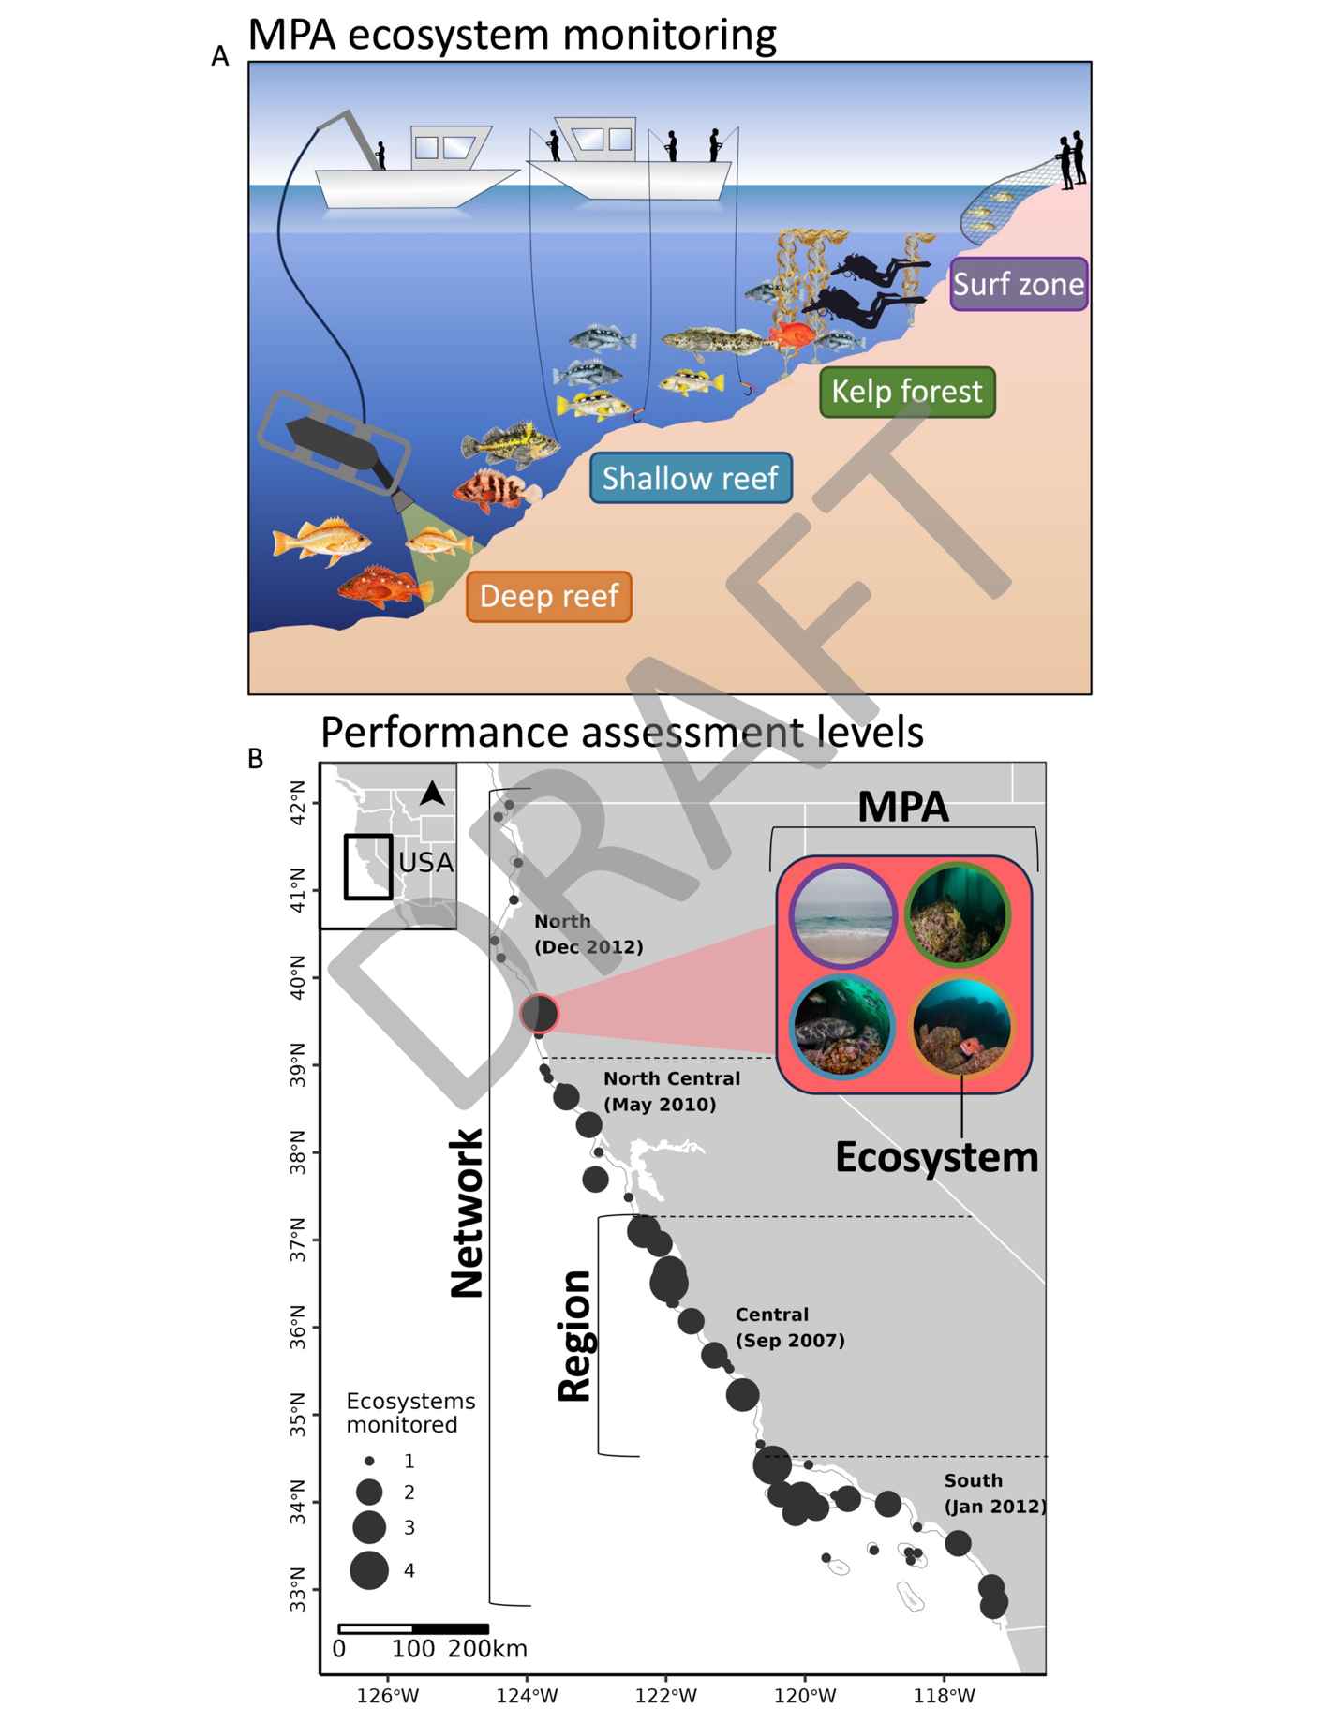

**Figure 1.** Ecosystem sampling methods and monitoring sites in California’s network of marine protected areas (MPAs). In **(A)**, the general sampling methods are shown for the surf zone (seine), kelp forest (scuba surveys), shallow reef (hook-and-line), and deep reef (remotely operated vehicle) ecosystems. In **(B)**, MPAs sampled (*n =* 59) by any ecosystem are shown as black circles, and the circle size corresponds to the number of ecosystems that sampled a given MPA. Four levels of assessing MPA performance are conceptual depicted: ecosystem-level (analysis for a single ecosystem across sampled MPAs), MPA-level (performance assessment within individual MPAs across ecosystems), Regional (across MPAs and ecosystems within a region), and Network (across all ecosystems and MPAs for the network).



**Figure 2.** Biomass log response ratios by protection level (no-take vs. partial-take), ecosystem, and region for targeted (green) and non-targeted (purple) fish species. Each square represents the mean effect size across MPAs for a given region with 95% confidence intervals (upper bounds greater than 3 were truncated to ease visualization), and asterisks denote significance (*p* < 0.05). Square size represents the number of MPAs included in the effect size. The vertical line represents the line of no effect. Points to the right of the line indicate higher biomass in MPAs, and points to the left of the line indicate higher biomass outside of MPAs. The *Pooled* statistic below the horizontal line represents the meta-analytic effect size across all regions for a given ecosystem. The bottom panel depicts the pooled effect sizes across ecosystems for each region and across the entire MPA network. Finally, missing points indicate that MPAs were not sampled within a region for a given ecosystem.

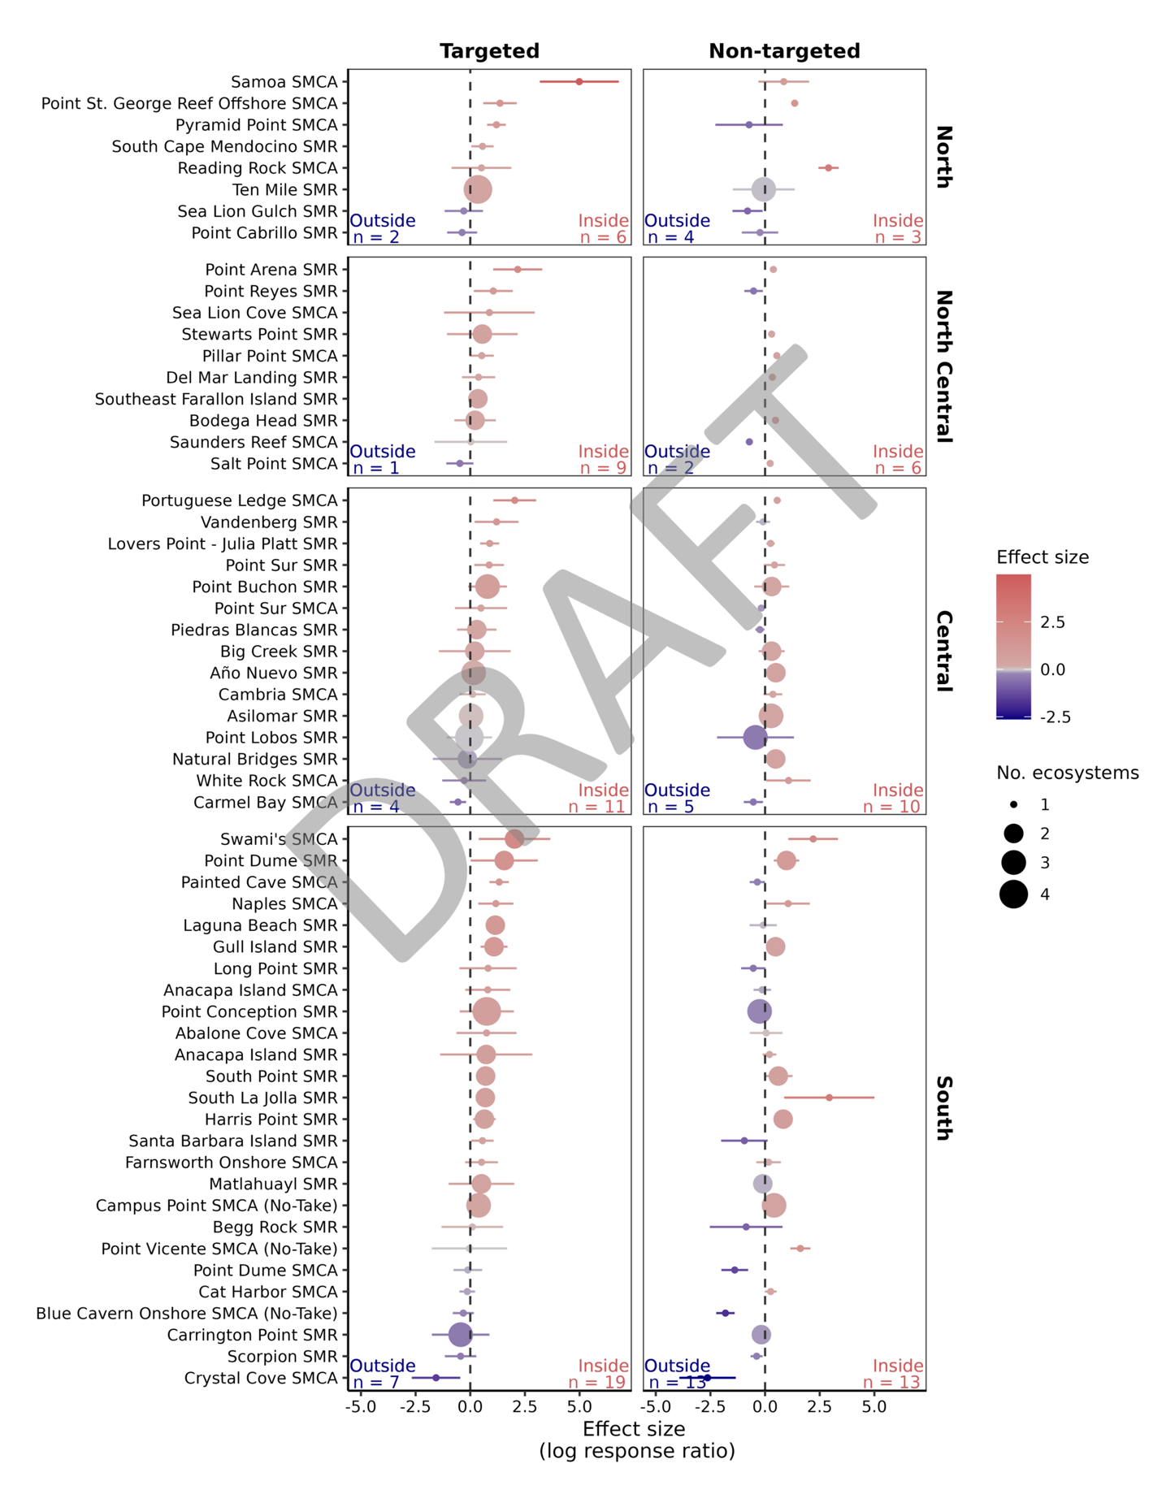

**Figure 3.** Biomass log response ratios for targeted (left) and non-targeted (right) fish species for 59 MPAs. Each point represents the weighted mean effect size (log response ratio) for a given MPA across all ecosystems (weighted by the inverse of the variance), and point size depicts the number of ecosystems included in the effect size. Each effect size was calculated for the most recent year of data to reflect the longest duration of protection for a given ecosystem. Error bars depict 95% confidence intervals. The vertical dashed line represents the null assumption of comparable biomass estimates inside (red) and outside (blue) of MPAs. Therefore, points to the right of the line indicate greater biomass inside the MPAs, and points to the left indicate greater biomass outside of MPAs. The number of MPAs (n) with positive (red) and negative (blue) response ratios are indicated in the lower corners of each panel.

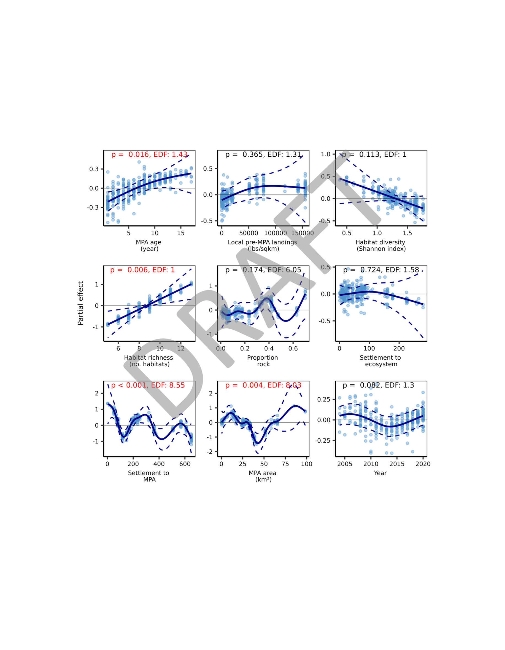

**Figure 4.** Partial effects of MPA features on performance from a meta-generalized additive model. Partial effects represent the smoothing term while holding all other variables constant. Solid blue lines depict the shape of the relationship between each MPA feature and performance (response ratio effect size), and dashed lines represent 95% confidence intervals. Residuals are shown as blue points. Also shown are p-values (p) for each relationship and the effective degrees of freedom (EDF) as a measure of flexibility.

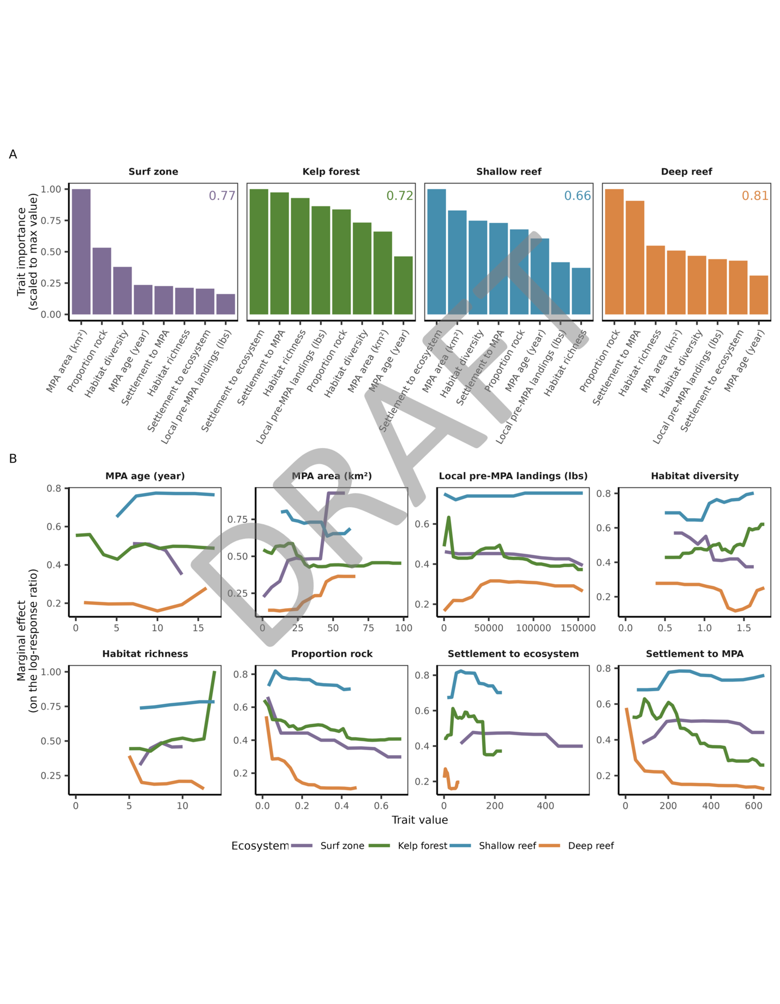

**Figure 5.** The **(A)** importance and **(B)** marginal effects of MPA traits on ecosystem-specific conservation performance (log-response ratio) for targeted species estimated by the random forest model. In **(A)**, trait importance is measured as the mean decrease in node impurity resulting from splitting on each trait scaled to the maximum value. MPA traits are sorted in order of decreasing importance. The r2 of each model fit is printed in the top-right corner of each plot. In **(B)**, lines indicate the ecosystem-specific impact of varying each MPA trait on conservation performance (log-response ratio) holding other traits at their means. Panels are arranged in descending rank-order (MPA age = highest, Settlement to MPA = lowest) based on the average impurity score across ecosystems.

## Supplementary Information

### Supplementary Methods

#### *Monitoring sampling design*

**Surf zone:** Surveys of surf zone fish at each MPA and reference site were conducted three times a year (June - November) during standardized tide windows (less than equal to 1 meter) and safe ocean conditions. On each survey date six beach seine hauls (net dimensions: 15.25 m long x 1.8 m high, 1 cm mesh with two poles attached on each end and central a 1.8 m x 1.8 m x 1.8 m bag) were conducted in the shallow surf zone (<1.5 m). Fish from each haul were identified, counted, and measured (standard and/or total length for the first 30 individuals of each species per haul) before being released at the capture site. For biomass estimates, we resampled from the size-frequency distribution of the 30 subsampled individuals to estimate the total length-frequency distribution of all individuals for a given haul.

**Kelp forest:** Replicate sampling sites are distributed within each MPA and at nearby “reference” sites of comparable habitat characteristics to those inside the MPA. Each survey site typically consists of a rectangular area, extending 150 m parallel with the shore. The onshore-offshore dimension varies depending on the width of the reef and the offshore distance of the 20 m isobath (depth). Typically, two to four sites inside and two to four sites outside each MPA were surveyed with the number and shape of sites varying depending on habitat (e.g., onshore-offshore steepness of the reef) and longshore width of the MPA. To characterize the ecological community throughout each sampling site, belt transects (30m x 2m) were distributed across a depth gradient from the 5 m to the 20 m isobath at each site. Surveys were generally conducted in 1-2 visits to a site per year from June/July through October/November each year. Diver surveys were conducted to estimate the density and size distribution of all conspicuous fishes along replicate transects at three levels (bottom, midwater, canopy) in the water column. More details for each of the methods are described in [(Caselle et al., 2015; Hamilton et al., 2010; Malone et al., 2022)](https://www.zotero.org/google-docs/?05qDKj). For our analyses, we excluded canopy surveys because of temporal inconsistencies and combined the midwater and benthic surveys to estimate total fish density along replicate transects inside and outside of MPAs.

**Shallow reef:** Within the boundaries of each sampled MPA and reference area, 500 m by 500 m fixed grid cells were delineated in rocky habitats shallower than 40 m depth (to limit fishing mortality associated with barotrauma). Surveys were conducted annually along the Central Coast from 2007–2020 and expanded to the North and South Coasts in 2017. Volunteer anglers were recruited from various fishing clubs, online fishing websites, and from previous collaborative studies. Before each day of fishing, four grid cells in a given MPA or reference site were randomly chosen for sampling. Captains were instructed to locate three suitable fishing locations within each grid cell to complete fishing drifts with a goal of 15 minutes each. For each drift, information on the number of anglers, time spent fishing (minutes), location (GPS coordinates), depth (ft), habitat relief, and other environmental variables were recorded. Anglers used a standardized set of fishing gear across the entire state (shrimp flies with squid bait) and within regions to capture a variety of species and cover the spectrum of typical hook-and-line fishing gear used by anglers [(Starr et al., 2015; Yochum et al., 2011; Ziegler et al., 2022)](https://www.zotero.org/google-docs/?55bth3). Captured fishes were identified to species, measured to the nearest cm, and released. Lengths reported are total length, defined as the distance from the tip of the snout to the most posterior part of the caudal fin without compressing the tail.

**Deep reef:** Remotely Operated Vehicle (ROV) survey sites were initially identified using bathymetric bottom maps and then confirmed during exploratory ROV surveys. Sampling blocks that were 500 m wide and up to 3 km long were then created using GIS maps. Reference sites were selected based upon map-based estimations of similarity in the types and amounts of rocky substrate present, proximity to one another, and depth. A stratified-random design of transects was used and the ROV recorded video while moving along a fixed transect path along the seafloor. Thus, videos collected from 500 m long transect lines were used as sampling units. Video imagery collected was analyzed to characterize substrate types present and to identify and count all demersal and epibenthic finfish and macro-invertebrates. Using a series of non-overlapping video quadrats, the distribution, relative abundance, and density of species were estimated along each transect, as described in [(Auster et al., 1997)](https://www.zotero.org/google-docs/?w2Di7g) and [(Lindholm et al., 2004)](https://www.zotero.org/google-docs/?78gaxM). All organisms were identified, enumerated, and recorded with UTC timecode and linked to ROV position and sensor files. Forward digital still photographs were used to verify species identifications where high resolution of species characteristics was required. Estimates of fish lengths were made using paired lasers mounted on the ROV.

#### *Connectivity estimates*

We measured connectivity across the MPA network as the total summed settlement of propagules (spores, eggs, larvae) entering each MPA. To model propagule connectivity we used a Regional Ocean Model System (ROMS) particle tracking which simulates dispersal in three spatial dimensions (through the movement of X, Y, Z vectors) and one temporal dimension. This simulated dispersal is based on an average solution across 15 years (1999-2013) and the range spans from 100km south of CA into Baja California, Mexico and north up through Oregon, although for this project we focused on only California’s range. Approximately 88000 “propagule” particles are released across 557 ROMS cells (365 cells in California). Larvae move hourly, but with daily averaged currents (i.e., every hour we interpolate the daily average currents from the ROMS model in space and time to find the current at each particle location, then we move each particle with its appropriate current velocity). Landward of the 500 m depth isobath, larvae are also given a random kick simulating tidal currents of 5 cm/s. This kick is also given every hour in addition to the daily-averaged motion. Settlement only occurs within 10% of PLD (e.g., for PLD of 30 days: 27-33 days).

ROMS solutions were run at three “lengths of time” to simulate differing PLDs of common species’ life history: 30, 60 and 90 days. We then took an elemental average of the corresponding three PLD connectivity matrices to represent an average dispersal across common species inhabiting Rocky intertidal, Shallow Rocky Reef, 30-100m Rock and 100-200m Rock habitats. The ROMS output can be considered a measure of connectivity among cells (locations) but should not be considered – on its own – an estimate of one cell’s contribution of propagules to other cells. This is because cells in ROMS grids are only characterized by oceanographic forcing and spatial dimensions (and vertical layers), and we simulated the release of the same number of particles from each cell. To estimate the actual settlement of a species, propagule production for donor cells and amount of suitable habitat for receiving cells was incorporated based on the idea that propagules will scale with the amount of available habitat a species occupies in both donor and settlement locations. Specifically, across each habitat type we took the product of the donor to recipient cell propagule connectivity with the area of habitat in the donor cell and the area of habitat in the recipient cell. We then summed all propagule contributions coming from every donor cell (both MPAs and areas of fishing) into a recipient cell (MPAs only) to quantify total summed settlement across all MPAs within the network.

#### *Habitat estimates*

We examined the habitat richness, habitat diversity, and total proportion of rock within MPAs using estimates of the amount of major habitats present within the boundaries of each MPA (Table SX; below). Major habitats include both nearshore/offshore (0-3000 m depth) and onshore (shoreline) characteristics identified as important during the MLPA planning process. Habitat richness was calculated as the number of unique habitat types within each MPA. Habitat diversity was calculated as Shannon diversity using the area of each habitat type within the MPA. Proportion rock was calculated as the total area of hard substrate (across all depths) divided by the total size of the MPA.

### Supplementary Tables

**Table S1.** Observed species by ecosystem (Surf zone, kelp forest, Shallow reef, and Deep reef) and their target status.

|  |  |  |  |  |  |
| --- | --- | --- | --- | --- | --- |
| **Scientific name** | **Target status** | **Surf zone** | **Kelp forest** | **Shallow reef** | **Deep reef** |
| Agonidae spp | Non-targeted |  |  |  | X |
| Alopias vulpinus | Targeted |  | X | X |  |
| Ammodytes hexapterus | Targeted |  |  |  | X |
| Amphistichus argenteus | Targeted | X | X |  | X |
| Amphistichus koelzi | Targeted | X |  |  |  |
| Amphistichus rhodoterus | Targeted | X |  |  |  |
| Anarrhichthys ocellatus | Non-targeted |  | X | X | X |
| Anisotremus davidsonii | Targeted |  | X | X |  |
| Anoplagonus inermis | Non-targeted |  | X |  |  |
| Anoplopoma fimbria | Targeted |  |  |  | X |
| Apodichthys flavidus | Non-targeted |  | X |  |  |
| Apogon guadalupensis | Non-targeted |  | X |  |  |
| Apristurus brunneus | Non-targeted |  |  |  | X |
| Artedius harringtoni | Non-targeted |  |  | X |  |
| Atherinidae spp | Targeted | X |  |  |  |
| Atherinops affinis | Targeted | X |  | X |  |
| Atherinopsidae spp | Non-targeted |  | X | X |  |
| Atherinopsis californiensis | Targeted |  |  | X |  |
| Atractoscion nobilis | Targeted | X | X | X |  |
| Aulorhynchus flavidus | Non-targeted | X | X | X | X |
| Balistes polylepis | Non-targeted |  | X |  |  |
| Bathymasteridae spp | Non-targeted |  | X |  |  |
| Beringraja binoculata | Targeted |  | X |  | X |
| Beringraja rhina | Targeted |  |  |  | X |
| Beringraja stellulata | Targeted |  | X | X | X |
| Bothidae spp | Targeted |  | X |  |  |
| Brachygenys californiensis | Targeted |  | X | X |  |
| Brachyistius frenatus | Non-targeted | X | X |  | X |
| Caliraja spp | Targeted |  |  |  | X |
| Carcharhinus obscurus | Targeted |  | X |  |  |
| Caulolatilus princeps | Targeted |  | X | X | X |
| Cebidichthys violaceus | Targeted |  | X |  |  |
| Cephaloscyllium ventriosum | Non-targeted |  | X |  | X |
| Cheilotrema saturnum | Targeted | X | X |  |  |
| Chromis punctipinnis | Non-targeted |  | X | X | X |
| Citharichthys sordidus | Targeted |  | X | X | X |
| Citharichthys spp | Targeted |  | X | X |  |
| Citharichthys stigmaeus | Targeted | X | X | X |  |
| Citharichthys xanthostigma | Targeted |  |  | X |  |
| Clinidae spp | Non-targeted | X |  |  |  |
| Clupea pallasii | Targeted | X |  |  |  |
| Cottidae spp | Non-targeted |  |  |  | X |
| Cryptacanthodes giganteus | Non-targeted |  | X |  |  |
| Cymatogaster aggregata | Targeted | X | X |  | X |
| Decapterus macarellus | Targeted |  | X |  |  |
| Embiotoca jacksoni | Targeted | X | X |  | X |
| Embiotoca lateralis | Targeted | X | X | X | X |
| Embiotocidae spp | Targeted |  | X |  | X |
| Engraulis mordax | Targeted | X | X | X |  |
| Enophrys bison | Non-targeted |  | X | X | X |
| Enophrys taurina | Non-targeted |  |  | X |  |
| Entosphenus tridentatus | Non-targeted |  |  |  | X |
| Eopsetta jordani | Targeted |  |  | X | X |
| Eptatretus stoutii | Targeted |  |  |  | X |
| Ernogrammus walkeri | Non-targeted |  | X |  |  |
| Fundulus parvipinnis | Non-targeted | X |  |  |  |
| Gadidae spp | Non-targeted |  |  |  | X |
| Galeorhinus galeus | Targeted |  | X | X |  |
| Genyonemus lineatus | Targeted | X |  | X |  |
| Gibbonsia metzi | Non-targeted | X |  |  | X |
| Gibbonsia montereyensis | Non-targeted | X |  |  |  |
| Gibbonsia spp | Non-targeted | X |  |  |  |
| Girella nigricans | Targeted | X | X | X | X |
| Glyptocephalus zachirus | Targeted |  |  |  | X |
| Gobiesox maeandricus | Non-targeted |  | X |  |  |
| Gobiidae spp | Non-targeted |  |  |  | X |
| Gymnothorax mordax | Non-targeted |  | X |  | X |
| Halichoeres semicinctus | Non-targeted |  | X | X | X |
| Hemilepidotus hemilepidotus | Non-targeted |  | X |  |  |
| Hemilepidotus spinosus | Non-targeted |  | X |  |  |
| Heterodontus francisci | Non-targeted |  | X |  | X |
| Heterostichus rostratus | Non-targeted | X | X |  |  |
| Hexagrammidae spp | Targeted |  |  |  | X |
| Hexagrammos decagrammus | Targeted |  | X | X | X |
| Hexagrammos lagocephalus | Targeted |  | X | X | X |
| Hexagrammos spp | Targeted |  | X |  |  |
| Hexanchus griseus | Targeted |  | X |  | X |
| Hippoglossina stomata | Targeted |  |  | X |  |
| Hippoglossus stenolepis | Targeted |  |  | X | X |
| Hydrolagus colliei | Non-targeted |  |  |  | X |
| Hyperprosopon anale | Targeted | X | X |  |  |
| Hyperprosopon argenteum | Targeted | X | X |  |  |
| Hyperprosopon ellipticum | Targeted | X | X |  |  |
| Hypomesus pretiosus | Targeted | X |  |  |  |
| Hypsurus caryi | Targeted | X | X |  | X |
| Hypsypops rubicundus | Non-targeted |  | X | X | X |
| Kyphosus azureus | Targeted | X | X |  |  |
| Leiocottus hirundo | Non-targeted |  | X |  |  |
| Lepidopsetta bilineata | Targeted |  |  | X | X |
| Leptocottus armatus | Non-targeted | X | X |  | X |
| Lethops connectens | Non-targeted |  | X |  |  |
| Lycodes pacificus | Targeted |  |  |  | X |
| Lyopsetta exilis | Targeted |  |  |  | X |
| Lythrypnus dalli | Non-targeted |  |  |  | X |
| Macrouridae spp | Non-targeted |  |  |  | X |
| Medialuna californiensis | Targeted | X | X | X | X |
| Menticirrhus undulatus | Targeted | X |  |  |  |
| Merluccius productus | Targeted |  |  |  | X |
| Micrometrus aurora | Non-targeted | X |  |  |  |
| Micrometrus minimus | Non-targeted | X | X |  |  |
| Microstomus pacificus | Targeted |  |  |  | X |
| Mola mola | Non-targeted |  | X |  | X |
| Morone saxatilis | Targeted | X |  |  |  |
| Mugil cephalus | Targeted | X |  |  |  |
| Myliobatis californica | Targeted | X | X | X | X |
| Neoclinus blanchardi | Non-targeted |  | X | X |  |
| Notorynchus cepedianus | Targeted |  | X |  |  |
| Oncorhynchus tshawytscha | Targeted |  |  | X |  |
| Ophiodon elongatus | Targeted |  | X | X | X |
| Osmeridae spp | Targeted |  |  |  | X |
| Oxyjulis californica | Non-targeted |  | X | X | X |
| Oxylebius pictus | Non-targeted |  | X | X | X |
| Paralabrax clathratus | Targeted | X | X | X | X |
| Paralabrax maculatofasciatus | Targeted |  | X |  |  |
| Paralabrax nebulifer | Targeted |  | X | X |  |
| Paralichthyidae spp | Targeted | X |  |  | X |
| Paralichthys californicus | Targeted | X | X | X | X |
| Parophrys vetulus | Targeted |  |  |  | X |
| Pegusa lascaris | Targeted |  |  |  | X |
| Phanerodon atripes | Non-targeted |  | X | X | X |
| Phanerodon furcatus | Targeted | X | X |  | X |
| Phanerodon vacca | Targeted | X | X | X | X |
| Pholidae spp | Non-targeted | X | X |  |  |
| Platichthys stellatus | Targeted | X |  |  | X |
| Platyrhinoidis triseriata | Non-targeted | X | X |  |  |
| Pleuronectidae spp | Targeted |  | X |  | X |
| Pleuronichthys coenosus | Non-targeted |  | X |  |  |
| Pleuronichthys ritteri | Non-targeted |  |  |  | X |
| Porichthys notatus | Non-targeted |  | X |  | X |
| Prionace glauca | Targeted |  | X |  |  |
| Prognathodes falcifer | Non-targeted |  | X |  |  |
| Psettichthys melanostictus | Targeted | X |  | X |  |
| Pseudobatos productus | Targeted | X | X |  |  |
| Rajidae spp | Targeted |  |  |  | X |
| Rathbunella alleni | Non-targeted |  | X |  |  |
| Rathbunella hypoplecta | Non-targeted |  | X |  | X |
| Rhacochilus toxotes | Targeted |  | X | X | X |
| Rhamphocottus richardsonii | Non-targeted |  | X |  |  |
| Rhinogobiops nicholsii | Non-targeted |  | X |  | X |
| Roncador stearnsii | Targeted | X |  |  |  |
| Ronquilus jordani | Non-targeted |  | X |  |  |
| Sarda chiliensis | Targeted |  | X | X |  |
| Sardinops sagax | Targeted | X | X | X |  |
| Sciaenidae spp | Targeted |  |  |  | X |
| Scomber japonicus | Targeted |  | X | X |  |
| Scombridae spp | Targeted |  |  | X |  |
| Scorpaena guttata | Targeted |  | X | X | X |
| Scorpaenichthys marmoratus | Targeted | X | X | X | X |
| Scorpaenidae spp | Targeted |  |  |  | X |
| Scorpaenodes xyris | Non-targeted |  | X |  |  |
| Sebastes atrovirens | Targeted |  | X | X | X |
| Sebastes auriculatus | Targeted |  | X | X | X |
| Sebastes aurora | Targeted |  |  |  | X |
| Sebastes babcocki | Non-targeted |  |  |  | X |
| Sebastes borealis | Targeted |  |  |  | X |
| Sebastes carnatus | Targeted |  | X | X | X |
| Sebastes caurinus | Targeted |  | X | X | X |
| Sebastes chlorostictus | Targeted |  |  |  | X |
| Sebastes chrysomelas | Targeted |  | X | X | X |
| Sebastes constellatus | Targeted |  |  | X | X |
| Sebastes crameri | Targeted |  |  |  | X |
| Sebastes dallii | Targeted |  | X | X | X |
| Sebastes diaconus | Targeted |  |  | X |  |
| Sebastes diploproa | Targeted |  | X |  | X |
| Sebastes elongatus | Targeted |  |  |  | X |
| Sebastes ensifer | Targeted |  |  |  | X |
| Sebastes entomelas | Targeted |  | X | X | X |
| Sebastes flavidus | Targeted |  |  | X | X |
| Sebastes goodei | Targeted |  |  |  | X |
| Sebastes helvomaculatus | Non-targeted |  |  |  | X |
| Sebastes hopkinsi | Targeted |  | X | X | X |
| Sebastes jordani | Targeted |  |  |  | X |
| Sebastes lentiginosus | Targeted |  |  | X | X |
| Sebastes levis | Targeted |  |  |  | X |
| Sebastes maliger | Targeted |  | X | X | X |
| Sebastes melanops | Targeted |  | X | X | X |
| Sebastes melanostomus | Targeted |  |  |  | X |
| Sebastes miniatus | Targeted |  | X | X | X |
| Sebastes mystinus | Targeted |  | X | X | X |
| Sebastes nebulosus | Targeted |  | X | X | X |
| Sebastes nigrocinctus | Targeted |  |  | X | X |
| Sebastes ovalis | Targeted |  |  |  | X |
| Sebastes paucispinis | Targeted | X | X | X | X |
| Sebastes pinniger | Targeted |  | X | X | X |
| Sebastes rastrelliger | Targeted | X | X | X |  |
| Sebastes rosaceus | Targeted |  | X | X | X |
| Sebastes rosenblatti | Targeted |  |  |  | X |
| Sebastes ruberrimus | Targeted |  |  | X | X |
| Sebastes rubrivinctus | Targeted |  | X |  | X |
| Sebastes rufus | Targeted |  |  |  | X |
| Sebastes saxicola | Targeted |  | X |  | X |
| Sebastes semicinctus | Targeted |  | X |  | X |
| Sebastes serranoides | Targeted |  |  | X | X |
| Sebastes serriceps | Targeted |  | X | X | X |
| Sebastes simulator | Targeted |  |  |  | X |
| Sebastes spp | Targeted | X | X | X | X |
| Sebastes umbrosus | Targeted |  | X | X | X |
| Sebastes wilsoni | Non-targeted |  |  |  | X |
| Sebastidae spp | Targeted |  |  |  | X |
| Sebastolobus alascanus | Targeted |  |  |  | X |
| Semicossyphus pulcher | Targeted |  | X | X | X |
| Seriola lalandi | Targeted |  | X | X | X |
| Seriphus politus | Targeted | X |  |  |  |
| Sphyraena argentea | Targeted |  | X | X |  |
| Squalus acanthias | Targeted |  | X | X |  |
| Squatina californica | Targeted |  | X |  | X |
| Stellerina xyosterna | Non-targeted | X |  |  |  |
| Stereolepis gigas | Non-targeted |  | X | X | X |
| Stichaeidae spp | Non-targeted |  | X |  |  |
| Syngnathus californiensis | Non-targeted | X |  |  |  |
| Syngnathus leptorhynchus | Non-targeted | X |  |  |  |
| Syngnathus spp | Non-targeted | X | X |  |  |
| Synodus lucioceps | Non-targeted |  | X | X | X |
| Tetronarce californica | Non-targeted |  | X |  | X |
| Thaleichthys pacificus | Targeted |  | X |  |  |
| Trachurus symmetricus | Targeted |  | X | X |  |
| Triakis semifasciata | Targeted | X | X |  |  |
| Ulvicola sanctaerosae | Non-targeted |  | X |  |  |
| Umbrina roncador | Targeted | X |  | X |  |
| Urobatis halleri | Targeted | X | X |  |  |
| Xystreurys liolepis | Targeted |  |  | X |  |
| Zalembius rosaceus | Non-targeted |  | X |  | X |
| Zaniolepis frenata | Non-targeted |  |  |  | X |
| Zaniolepis latipinnis | Non-targeted |  |  |  | X |
| Zaniolepis spp | Non-targeted |  |  |  | X |
| Zapteryx exasperata | Targeted |  | X |  |  |
| Zoarcidae spp | Non-targeted | X |  |  | X |

**Table S2.** MPA traits used to predict conservation performance.

|  |  |  |  |
| --- | --- | --- | --- |
| **Category** | **Trait** | **Source** | **Details** |
| MPA trait | MPA age (yr) | CDFW MPA GIS file |  |
| MPA trait | MPA size (km2) | CDFW MPA GIS file |  |
| MPA trait | Regulatory status | CDFW MPA GIS file |  |
| Habitat | Connectivity |  | Simulated using ROMS (see supplementary *Methods*) |
| Habitat | Habitat richness | CDFW bottom substrate and ESI shoreline | Number of unique habitat types |
| Habitat | Habitat diversity | CDFW bottom substrate and ESI shoreline | Shannon diversity using area of each habitat type |
| Habitat | Proportion of rock bottom | CDFW bottom substrate | Total hard substrate divided by MPA size |
| Human | Pre-MPA fishing pressure | CDFW fish tickets |  |
| Biological | Species traits | Kelp forest + FishBase |  |

**Table S3.**Habitat types and data sources used to estimate habitat diversity, habitat richness, and proportion of rock within each MPA.

|  |  |
| --- | --- |
| **Habitat Type** | **Data Information** |
| Hard substrate (0-30m) | High resolution (2m to 10m) multibeam mapping, mostly from the [California Seafloor Mapping Project](https://csumb.edu/undersea/seafloor-maps/). Area totals calculated from a vector file. Depth information from the high resolution bathymetry data where available. Small mapping gaps filled in through interpolation and added to the total. |
| Hard substrate (30-100m) |
| Hard substrate (100-200m) |
| Hard substrate (200-3000m) |
| Soft substrate (0-30m) |
| Soft substrate (30-100m) |
| Soft substrate (100-200m) |
| Soft substrate (200-3000m) |
| Kelp canopy (0-30m) | Data from CDFW kelp overflights (14 years; '89, '99, '02-'06, '08-'10, '13-'16), composite of all available data for maximum canopy extent.(Saarman 2020, unpublished). Captures both giant and bull kelp and covers the whole coast of California. |
| Coastal marsh | Data from [NOAA ESI shoreline](https://response.restoration.noaa.gov/resources/environmental-sensitivity-index-esi-maps) data, using the 2010 update for southern California. Source data has up to 3 classifications for each coastal segment (landward, seaward1, seaward2), length totals reflect all of these classifications, but do not double-count (for example landward is gravel beach, seaward1 is fine-grained beach, this segment counted just once as beach). Linear estimates were converted to area using median beach widths. |
| Tidal flats |
| Hardened/armored shoreline |
| Sandy beach |
| Rocky intertidal |

**Table S4.** List of de-facto MPAs for each ecosystem. MPA type is the state-designated status of the MPA, and the de-factostatus is indicated for each ecosystem. Empty cells indicate that particular MPA was not sampled by a given ecosystem.

|  |  |  |  |  |  |
| --- | --- | --- | --- | --- | --- |
| **MPA name** | **MPA type** | **Surf zone** | **Kelp forest** | **Shallow reef** | **Deep reef** |
| Campus Point SMCA | SMCA | SMR | SMR |  | SMR |
| White Rock SMCA | SMCA |  | SMR |  |  |
| Point Vicente SMCA | SMCA |  | SMR |  |  |
| Blue Cavern Onshore SMCA | SMCA |  | SMR |  |  |
| Abalone Cove SMCA | SMCA |  | SMR |  |  |
| Farnsworth Onshore SMCA | SMCA |  | SMR |  |  |
| Point Dume SMCA | SMCA |  | SMR |  |  |
| Swami's SMCA | SMCA |  | SMR | SMR |  |
| Piedras Blancas SMCA | SMCA |  |  |  | SMR |
| Point Sur SMCA | SMCA |  |  |  | SMR |
| Southeast Farallon Island SMCA | SMCA |  |  |  | SMR |
| Point Arena SMCA | SMCA |  |  |  | SMR |
| Portuguese Ledge SMCA | SMCA |  |  |  | SMR |
| Big Creek SMCA | SMCA |  |  |  | SMR |

**Table S5.** Sampling years by ecosystem for MPAs with paired reference sites. Empty cells indicate that particular MPA was not sampled by a given ecosystem.

|  |  |  |  |  |
| --- | --- | --- | --- | --- |
| **MPA name** | **Surf zone** | **Kelp forest** | **Shallow reef** | **Deep reef** |
| Abalone Cove SMCA |  | 2011, 2013, 2015, 2016, 2017, 2018, 2019, 2020 |  |  |
| Anacapa Island SMCA |  | 2004, 2005, 2006, 2007, 2008, 2009 |  |  |
| Anacapa Island SMR |  | 2004, 2005, 2006, 2007, 2008, 2009, 2010, 2011, 2012, 2014, 2015, 2016, 2017, 2018, 2019, 2020 | 2017, 2018, 2019, 2020 |  |
| Asilomar SMR | 2019, 2020 | 2007, 2008, 2011 |  | 2007, 2008 |
| Año Nuevo SMR | 2019, 2020 |  | 2007, 2008, 2009, 2010, 2011, 2012, 2013, 2014, 2015, 2016, 2017, 2018, 2019, 2020 | 2015, 2019 |
| Begg Rock SMR |  | 2009, 2013 |  |  |
| Big Creek SMR |  | 2001, 2002, 2003, 2004, 2005, 2006, 2007, 2008, 2009, 2010, 2011, 2015 |  | 2016 |
| Blue Cavern Onshore SMCA |  | 2004, 2011, 2012, 2019, 2020 |  |  |
| Bodega Head SMR |  |  | 2017, 2018, 2019, 2020 | 2015, 2019 |
| Cambria SMCA |  | 2003, 2004, 2005, 2007, 2008 |  |  |
| Campus Point SMCA | 2019, 2020 | 2009, 2010, 2011, 2012, 2013, 2014, 2015, 2016, 2017, 2018, 2019, 2020 |  | 2014, 2019 |
| Carmel Bay SMCA |  | 2001, 2002, 2003, 2004, 2005, 2006, 2007, 2008, 2009, 2010, 2011, 2013, 2014, 2015, 2016, 2017, 2018, 2019, 2020 |  |  |
| Carrington Point SMR |  | 2003, 2004, 2005, 2007, 2008 | 2017, 2018, 2019, 2020 | 2005, 2006, 2007, 2009, 2014, 2019 |
| Cat Harbor SMCA |  | 2004, 2005, 2011, 2012, 2019, 2020 |  |  |
| Crystal Cove SMCA |  | 2011, 2012, 2019, 2020 |  |  |
| Del Mar Landing SMR |  | 2010, 2011 |  |  |
| Farnsworth Onshore SMCA |  | 2011, 2012, 2019 |  |  |
| Gull Island SMR |  | 2003, 2004, 2005, 2006, 2007, 2008, 2009, 2010, 2011, 2012, 2014, 2015, 2016, 2017, 2018, 2019, 2020 |  | 2014, 2019 |
| Harris Point SMR |  | 2003, 2004, 2005, 2006, 2007, 2008, 2009, 2010, 2011, 2012, 2014, 2016, 2018, 2019, 2020 |  | 2005, 2006, 2007, 2009, 2014, 2019 |
| Laguna Beach SMR | 2019, 2020 |  | 2017 |  |
| Long Point SMR |  | 2011, 2012, 2019, 2020 |  |  |
| Lovers Point - Julia Platt SMR |  | 2000, 2001, 2002, 2003, 2004, 2005, 2006, 2007, 2008, 2009, 2011, 2012, 2013, 2014, 2015, 2016, 2017, 2018, 2019, 2020 |  |  |
| Matlahuayl SMR | 2019, 2020 | 2011, 2012, 2019, 2020 |  |  |
| Naples SMCA |  | 2009, 2010, 2011, 2012, 2013, 2014, 2015, 2016, 2017, 2018, 2019, 2020 |  |  |
| Natural Bridges SMR | 2019, 2020 | 2000, 2001, 2002, 2003, 2004, 2005, 2006, 2007, 2008, 2009, 2010, 2011 |  |  |
| Painted Cave SMCA |  | 2003, 2004, 2005, 2006, 2007, 2008, 2009, 2010, 2011, 2012, 2014, 2015, 2016, 2017, 2018, 2019, 2020 |  |  |
| Piedras Blancas SMR |  | 2003, 2004, 2005, 2006, 2007, 2008 | 2008, 2009, 2010, 2011, 2012, 2013, 2014, 2016, 2017, 2018, 2019, 2020 |  |
| Pillar Point SMCA |  |  |  | 2015 |
| Point Arena SMR |  | 2011 |  |  |
| Point Buchon SMR |  | 2007, 2008, 2009, 2010, 2011, 2016, 2017, 2018, 2019, 2020 | 2007, 2008, 2009, 2010, 2011, 2012, 2013, 2014, 2015, 2016, 2017, 2018, 2019, 2020 | 2008, 2009, 2016, 2019 |
| Point Cabrillo SMR |  | 2014, 2015, 2017, 2018, 2019 |  |  |
| Point Conception SMR | 2019, 2020 | 2000, 2001, 2002, 2003, 2004, 2005, 2006, 2007, 2009, 2010, 2011, 2012 | 2018 | 2014, 2019 |
| Point Dume SMCA |  | 2010, 2011, 2012, 2013, 2019, 2020 |  |  |
| Point Dume SMR | 2019, 2020 | 2008, 2019, 2020 |  |  |
| Point Lobos SMR | 2019, 2020 | 2006, 2007, 2008, 2009, 2010, 2011, 2012, 2013, 2014, 2015, 2016, 2017, 2018, 2019, 2020 | 2007, 2008, 2009, 2010, 2011, 2012, 2013, 2014, 2015, 2016, 2017, 2018, 2019, 2020 | 2008, 2009, 2016, 2019 |
| Point Reyes SMR | 2019, 2020 |  |  |  |
| Point St. George Reef Offshore SMCA |  |  |  | 2014 |
| Point Sur SMCA |  |  |  | 2008 |
| Point Sur SMR |  | 2005, 2006, 2007, 2008, 2010, 2011, 2017, 2019, 2020 |  |  |
| Point Vicente SMCA |  | 2004, 2007, 2008, 2009, 2010, 2011, 2012, 2013, 2014, 2015, 2016, 2017, 2018, 2019, 2020 |  |  |
| Portuguese Ledge SMCA |  |  |  | 2016, 2019 |
| Pyramid Point SMCA |  | 2018 |  |  |
| Reading Rock SMCA | 2019, 2020 |  |  |  |
| Salt Point SMCA |  | 2010, 2011 |  |  |
| Samoa SMCA | 2019, 2020 |  |  |  |
| Santa Barbara Island SMR |  | 2004, 2005, 2006, 2007, 2008, 2011, 2013, 2019 |  |  |
| Saunders Reef SMCA |  | 2010, 2011, 2016, 2017, 2018, 2019, 2020 |  |  |
| Scorpion SMR |  | 2004, 2005, 2006, 2007, 2008, 2009, 2010, 2011, 2012, 2013, 2014, 2015, 2016, 2017, 2018, 2019, 2020 |  |  |
| Sea Lion Cove SMCA |  | 2010, 2011 |  |  |
| Sea Lion Gulch SMR |  |  |  | 2014 |
| South Cape Mendocino SMR |  |  | 2017, 2018, 2019, 2020 |  |
| South La Jolla SMR |  | 2011, 2012, 2019, 2020 | 2017, 2018, 2019, 2020 |  |
| South Point SMR |  | 2004, 2005, 2006, 2007, 2008, 2009, 2010, 2011, 2012, 2013, 2014, 2015, 2016, 2017, 2018, 2019, 2020 |  | 2005, 2006, 2007, 2009, 2014, 2019 |
| Southeast Farallon Island SMR |  |  | 2017, 2018 | 2011 |
| Stewarts Point SMR |  | 2010, 2011, 2017, 2018, 2019 | 2017, 2018, 2019, 2020 |  |
| Swami's SMCA |  | 2011, 2012, 2019 | 2017, 2018, 2019, 2020 |  |
| Ten Mile SMR | 2019, 2020 | 2014, 2015, 2018, 2019, 2020 | 2017, 2018, 2019, 2020 | 2014 |
| Vandenberg SMR |  | 2000, 2001, 2002, 2003, 2004, 2005, 2006, 2008 |  |  |
| White Rock SMCA |  | 2003, 2004, 2005, 2006, 2007, 2008, 2009, 2011 |  |  |

**Table S6.** Network-level meta analysis results pooled across the entire network of MPAs, ecosystems, and regions.

|  |  |  |  |  |  |  |  |  |  |  |
| --- | --- | --- | --- | --- | --- | --- | --- | --- | --- | --- |
| **MPA**  **type** | **Allowed take** | **Target status** | **Effect**  **size** | **Standard error** | **P-value** | **95% lower** | **95% upper** | **No. MPA-Ecosystem pairs** | **Tau-2** | **Q** |
| SMCA | Partial-take | Targeted | 0.587 | 0.314 | 0.062 | -0.029 | 1.203 | 15 | 1.237 | 119.856 |
| SMR | No-take | Targeted | 0.491 | 0.096 | <0.001 | 0.304 | 0.679 | 78 | 0.561 | 984.041 |
| SMCA | Partial-take | Nontargeted | 0.224 | 0.319 | 0.482 | -0.4 | 0.849 | 14 | 1.307 | 5843.407 |
| SMR | No-take | Nontargeted | 0.159 | 0.087 | 0.069 | -0.012 | 0.33 | 62 | 0.382 | 639.999 |

**Table S7.** Regional-level meta analysisresults from meta analyses pooled across MPAs and ecosystems within a region.

|  |  |  |  |  |  |  |  |  |  |  |  |
| --- | --- | --- | --- | --- | --- | --- | --- | --- | --- | --- | --- |
| **Region** | **MPA type** | **Allowed take** | **Target status** | **Effect size** | **Standard error** | **P-val** | **95% lower** | **95% upper** | **No. MPA-Ecosystem pairs** | **Tau-2** | **Q** |
| North Coast | SMCA | Partial-take | Targeted | 1.901 | 0.912 | 0.037 | 0.115 | 3.688 | 4 | 2.967 | 17.48 |
| North Coast | SMR | No-take | Targeted | 0.215 | 0.194 | 0.268 | -0.165 | 0.596 | 7 | 0.165 | 17.738 |
| North Coast | SMCA | Partial-take | Nontargeted | 1.22 | 0.721 | 0.09 | -0.192 | 2.633 | 4 | 1.849 | 50.963 |
| North Coast | SMR | No-take | Nontargeted | -0.176 | 0.407 | 0.666 | -0.973 | 0.621 | 5 | 0.681 | 27.055 |
| North Central Coast | SMCA | Partial-take | Targeted | 0.114 | 0.349 | 0.744 | -0.57 | 0.798 | 4 | 0.223 | 6.086 |
| North Central Coast | SMR | No-take | Targeted | 0.582 | 0.244 | 0.017 | 0.104 | 1.061 | 9 | 0.428 | 86.266 |
| North Central Coast | SMCA | Partial-take | Nontargeted | 0.017 | 0.378 | 0.965 | -0.725 | 0.758 | 3 | 0.428 | 548.886 |
| North Central Coast | SMR | No-take | Nontargeted | 0.243 | 0.142 | 0.087 | -0.035 | 0.522 | 5 | 0.094 | 36.958 |
| Central Coast | SMCA | Partial-take | Targeted | -0.271 | 0.331 | 0.414 | -0.92 | 0.379 | 2 | 0.158 | 3.432 |
| Central Coast | SMR | No-take | Targeted | 0.358 | 0.154 | 0.02 | 0.056 | 0.661 | 25 | 0.452 | 168.822 |
| Central Coast | SMCA | Partial-take | Nontargeted | -0.088 | 0.447 | 0.844 | -0.964 | 0.788 | 2 | 0.351 | 8.165 |
| Central Coast | SMR | No-take | Nontargeted | 0.228 | 0.123 | 0.064 | -0.013 | 0.468 | 21 | 0.254 | 227.005 |
| South Coast | SMCA | Partial-take | Targeted | 0.359 | 0.508 | 0.48 | -0.637 | 1.355 | 5 | 1.132 | 41.364 |
| South Coast | SMR | No-take | Targeted | 0.627 | 0.156 | <0.001 | 0.321 | 0.932 | 37 | 0.724 | 599.105 |
| South Coast | SMCA | Partial-take | Nontargeted | -0.289 | 0.534 | 0.588 | -1.337 | 0.758 | 5 | 1.289 | 27.991 |
| South Coast | SMR | No-take | Nontargeted | 0.15 | 0.148 | 0.311 | -0.14 | 0.439 | 31 | 0.554 | 308.952 |

**Table S8.** Ecosystem-levelmeta analysis results from meta analyses pooled across MPAs within an ecosystem and target status.

|  |  |  |  |  |  |  |  |  |  |  |  |
| --- | --- | --- | --- | --- | --- | --- | --- | --- | --- | --- | --- |
| **Ecosystem** | **MPA type** | **Allowed take** | **Target status** | **Effect size** | **Standard error** | **P-value** | **95% lower** | **95% upper** | **No. MPAs** | **Tau-2** | **Q** |
| Deep reef | SMCA | Partial-take | Targeted | 0.898 | 0.415 | 0.031 | 0.084 | 1.712 | 2 | 0.232 | 2.985 |
| Deep reef | SMR | No-take | Targeted | 0.185 | 0.163 | 0.254 | -0.133 | 0.504 | 17 | 0.296 | 54.662 |
| Deep reef | SMCA | Partial-take | Nontargeted | 0.948 | 0.409 | 0.021 | 0.146 | 1.749 | 2 | 0.333 | 282.304 |
| Deep reef | SMR | No-take | Nontargeted | 0.284 | 0.121 | 0.019 | 0.046 | 0.522 | 16 | 0.164 | 173.862 |
| Kelp forest | SMCA | Partial-take | Targeted | 0.251 | 0.28 | 0.371 | -0.299 | 0.8 | 11 | 0.672 | 86.105 |
| Kelp forest | SMR | No-take | Targeted | 0.461 | 0.163 | 0.005 | 0.141 | 0.781 | 35 | 0.743 | 659.659 |
| Kelp forest | SMCA | Partial-take | Nontargeted | -0.222 | 0.232 | 0.34 | -0.677 | 0.234 | 10 | 0.439 | 482.223 |
| Kelp forest | SMR | No-take | Nontargeted | 0.135 | 0.122 | 0.266 | -0.103 | 0.374 | 35 | 0.42 | 374.409 |
| Shallow reef | SMR | No-take | Targeted | 0.853 | 0.136 | <0.001 | 0.587 | 1.12 | 15 | 0.236 | 123.596 |
| Surf zone | SMCA | Partial-take | Targeted | 2.709 | 2.238 | 0.226 | -1.677 | 7.095 | 2 | 9.352 | 14.995 |
| Surf zone | SMR | No-take | Targeted | 0.486 | 0.282 | 0.085 | -0.066 | 1.038 | 11 | 0.653 | 61.019 |
| Surf zone | SMCA | Partial-take | Nontargeted | 1.951 | 1.022 | 0.056 | -0.052 | 3.954 | 2 | 1.896 | 10.332 |
| Surf zone | SMR | No-take | Nontargeted | 0.104 | 0.251 | 0.678 | -0.388 | 0.596 | 11 | 0.628 | 88.295 |

**Table S9.** Ecosystem-level meta analysis results by region.

|  |  |  |  |  |  |  |  |  |  |  |  |  |
| --- | --- | --- | --- | --- | --- | --- | --- | --- | --- | --- | --- | --- |
| **Ecosystem** | **Region** | **MPA**  **type** | **Allowed take** | **Target status** | **Effect**  **size** | **Standard error** | **P-value** | **95% lower** | **95% upper** | **No. MPAs** | **Tau-2** | **Q** |
| Deep reef | North | SMCA | Partial-take | Targeted | 1.359 | 0.392 | 0.001 | 0.592 | 2.127 | 1 | 0 | 0 |
| Deep reef | North | SMR | No-take | Targeted | -0.153 | 0.334 | 0.646 | -0.808 | 0.501 | 2 | 0 | 0.233 |
| Deep reef | North | SMCA | Partial-take | Nontargeted | 1.355 | 0.003 | <0.001 | 1.349 | 1.362 | 1 | 0 | 0 |
| Deep reef | North | SMR | No-take | Nontargeted | -1.109 | 0.487 | 0.023 | -2.064 | -0.155 | 2 | 0.208 | 1.557 |
| Deep reef | North Central | SMCA | Partial-take | Targeted | 0.524 | 0.283 | 0.064 | -0.031 | 1.079 | 1 | 0 | 0 |
| Deep reef | North Central | SMR | No-take | Targeted | -0.133 | 0.186 | 0.477 | -0.498 | 0.233 | 2 | 0 | 0.989 |
| Deep reef | North Central | SMCA | Partial-take | Nontargeted | 0.537 | 0.049 | <0.001 | 0.442 | 0.632 | 1 | 0 | 0 |
| Deep reef | North Central | SMR | No-take | Nontargeted | 0.478 | 0.033 | <0.001 | 0.414 | 0.542 | 1 | 0 | 0 |
| Deep reef | Central | SMR | No-take | Targeted | 0.083 | 0.344 | 0.81 | -0.592 | 0.757 | 7 | 0.632 | 26.222 |
| Deep reef | Central | SMR | No-take | Nontargeted | 0.302 | 0.136 | 0.027 | 0.035 | 0.569 | 7 | 0.097 | 110.697 |
| Deep reef | South | SMR | No-take | Targeted | 0.484 | 0.23 | 0.035 | 0.035 | 0.934 | 6 | 0.197 | 14.132 |
| Deep reef | South | SMR | No-take | Nontargeted | 0.506 | 0.179 | 0.005 | 0.154 | 0.857 | 6 | 0.108 | 17.21 |
| Kelp forest | North | SMCA | Partial-take | Targeted | 1.199 | 0.22 | <0.001 | 0.768 | 1.631 | 1 | 0 | 0 |
| Kelp forest | North | SMR | No-take | Targeted | -0.428 | 0.276 | 0.121 | -0.968 | 0.113 | 2 | 0 | 0.062 |
| Kelp forest | North | SMCA | Partial-take | Nontargeted | -0.731 | 0.788 | 0.354 | -2.275 | 0.813 | 1 | 0 | 0 |
| Kelp forest | North | SMR | No-take | Nontargeted | 0.218 | 0.259 | 0.4 | -0.29 | 0.727 | 2 | 0.089 | 1.981 |
| Kelp forest | North Central | SMCA | Partial-take | Targeted | -0.321 | 0.286 | 0.262 | -0.881 | 0.24 | 3 | 0 | 1.682 |
| Kelp forest | North Central | SMR | No-take | Targeted | 0.682 | 0.711 | 0.338 | -0.712 | 2.077 | 3 | 1.341 | 15.21 |
| Kelp forest | North Central | SMCA | Partial-take | Nontargeted | -0.243 | 0.476 | 0.61 | -1.176 | 0.69 | 2 | 0.452 | 444.855 |
| Kelp forest | North Central | SMR | No-take | Nontargeted | 0.343 | 0.025 | <0.001 | 0.294 | 0.391 | 3 | 0.001 | 8.748 |
| Kelp forest | Central | SMCA | Partial-take | Targeted | -0.271 | 0.331 | 0.414 | -0.92 | 0.379 | 2 | 0.158 | 3.432 |
| Kelp forest | Central | SMR | No-take | Targeted | 0.438 | 0.219 | 0.045 | 0.009 | 0.866 | 10 | 0.358 | 55.822 |
| Kelp forest | Central | SMCA | Partial-take | Nontargeted | -0.088 | 0.447 | 0.844 | -0.964 | 0.788 | 2 | 0.351 | 8.165 |
| Kelp forest | Central | SMR | No-take | Nontargeted | 0.212 | 0.117 | 0.069 | -0.017 | 0.441 | 10 | 0.086 | 59.421 |
| Kelp forest | South | SMCA | Partial-take | Targeted | 0.359 | 0.508 | 0.48 | -0.637 | 1.355 | 5 | 1.132 | 41.364 |
| Kelp forest | South | SMR | No-take | Targeted | 0.539 | 0.246 | 0.028 | 0.057 | 1.02 | 20 | 0.969 | 450.915 |
| Kelp forest | South | SMCA | Partial-take | Nontargeted | -0.289 | 0.534 | 0.588 | -1.337 | 0.758 | 5 | 1.289 | 27.991 |
| Kelp forest | South | SMR | No-take | Nontargeted | 0.078 | 0.223 | 0.725 | -0.359 | 0.516 | 20 | 0.843 | 205.663 |
| Shallow reef | North | SMR | No-take | Targeted | 0.609 | 0.147 | <0.001 | 0.322 | 0.897 | 2 | 0 | 0.056 |
| Shallow reef | North Central | SMR | No-take | Targeted | 0.841 | 0.313 | 0.007 | 0.228 | 1.455 | 3 | 0.251 | 26.794 |
| Shallow reef | Central | SMR | No-take | Targeted | 0.892 | 0.287 | 0.002 | 0.329 | 1.454 | 4 | 0.3 | 38.549 |
| Shallow reef | South | SMR | No-take | Targeted | 0.887 | 0.284 | 0.002 | 0.33 | 1.444 | 6 | 0.437 | 48.364 |
| Surf zone | North | SMCA | Partial-take | Targeted | 2.709 | 2.238 | 0.226 | -1.677 | 7.095 | 2 | 9.352 | 14.995 |
| Surf zone | North | SMR | No-take | Targeted | 0.613 | 0.087 | <0.001 | 0.443 | 0.782 | 1 | 0 | 0 |
| Surf zone | North | SMCA | Partial-take | Nontargeted | 1.951 | 1.022 | 0.056 | -0.052 | 3.954 | 2 | 1.896 | 10.332 |
| Surf zone | North | SMR | No-take | Nontargeted | 0.785 | 0.171 | <0.001 | 0.449 | 1.121 | 1 | 0 | 0 |
| Surf zone | North Central | SMR | No-take | Targeted | 1.053 | 0.454 | 0.02 | 0.162 | 1.944 | 1 | 0 | 0 |
| Surf zone | North Central | SMR | No-take | Nontargeted | -0.525 | 0.216 | 0.015 | -0.949 | -0.101 | 1 | 0 | 0 |
| Surf zone | Central | SMR | No-take | Targeted | -0.143 | 0.377 | 0.704 | -0.883 | 0.596 | 4 | 0.295 | 6.943 |
| Surf zone | Central | SMR | No-take | Nontargeted | -0.057 | 0.703 | 0.935 | -1.435 | 1.32 | 4 | 1.897 | 52.276 |
| Surf zone | South | SMR | No-take | Targeted | 0.789 | 0.486 | 0.104 | -0.163 | 1.742 | 5 | 0.958 | 36.967 |
| Surf zone | South | SMR | No-take | Nontargeted | 0.173 | 0.167 | 0.3 | -0.155 | 0.502 | 5 | 0.082 | 10.228 |

**Table S10.** MPA-level meta analysis results from meta analyses pooled across MPAs within an ecosystem, region, and target status.

|  |  |  |  |  |  |  |  |  |  |  |  |
| --- | --- | --- | --- | --- | --- | --- | --- | --- | --- | --- | --- |
|  | **Region** | **MPA name** | **Target status** | **Effect size** | **Standard error** | **P-value** | **95% lower** | **95% upper** | **Tau-2** | **Q** | **Ecosystem (latest year)** |
| 1 | North | Point Cabrillo SMR | Targeted | -0.374 | 0.35 | 0.285 | -1.06 | 0.311 | 0 | 0 | Kelp forest (2019) |
| 1 | North | Point Cabrillo SMR | Non-targeted | -0.232 | 0.426 | 0.585 | -1.067 | 0.602 | 0 | 0 | Kelp forest (2019) |
| 2 | North | Sea Lion Gulch SMR | Targeted | -0.297 | 0.447 | 0.506 | -1.173 | 0.579 | 0 | 0 | Deep reef (2014) |
| 2 | North | Sea Lion Gulch SMR | Non-targeted | -0.802 | 0.352 | 0.023 | -1.492 | -0.111 | 0 | 0 | Deep reef (2014) |
| 3 | North | Ten Mile SMR | Targeted | 0.352 | 0.237 | 0.137 | -0.111 | 0.816 | 0.142 | 7.409 | Surf zone (2019), Kelp forest (2020), Shallow reef (2020), Deep reef (2014) |
| 3 | North | Ten Mile SMR | Non-targeted | -0.061 | 0.723 | 0.933 | -1.477 | 1.355 | 1.395 | 14 | Surf zone (2020), Kelp forest (2020), Deep reef (2014) |
| 4 | North | Reading Rock SMCA | Targeted | 0.511 | 0.698 | 0.463 | -0.856 | 1.879 | 0 | 0 | Surf zone (2020) |
| 4 | North | Reading Rock SMCA | Non-targeted | 2.903 | 0.235 | 0 | 2.442 | 3.365 | 0 | 0 | Surf zone (2020) |
| 5 | North | South Cape Mendocino SMR | Targeted | 0.559 | 0.26 | 0.032 | 0.049 | 1.068 | 0 | 0 | Shallow reef (2020) |
| 6 | North | Pyramid Point SMCA | Targeted | 1.199 | 0.22 | 0 | 0.768 | 1.631 | 0 | 0 | Kelp forest (2018) |
| 6 | North | Pyramid Point SMCA | Non-targeted | -0.731 | 0.788 | 0.354 | -2.275 | 0.813 | 0 | 0 | Kelp forest (2018) |
| 7 | North | Point St. George Reef Offshore SMCA | Targeted | 1.359 | 0.392 | 0.001 | 0.592 | 2.127 | 0 | 0 | Deep reef (2014) |
| 7 | North | Point St. George Reef Offshore SMCA | Non-targeted | 1.355 | 0.003 | 0 | 1.349 | 1.362 | 0 | 0 | Deep reef (2014) |
| 8 | North | Samoa SMCA | Targeted | 4.988 | 0.922 | 0 | 3.181 | 6.795 | 0 | 0 | Surf zone (2020) |
| 8 | North | Samoa SMCA | Non-targeted | 0.854 | 0.592 | 0.149 | -0.307 | 2.015 | 0 | 0 | Surf zone (2020) |
| 9 | North Central | Salt Point SMCA | Targeted | -0.476 | 0.317 | 0.133 | -1.098 | 0.145 | 0 | 0 | Kelp forest (2011) |
| 9 | North Central | Salt Point SMCA | Non-targeted | 0.232 | 0.022 | 0 | 0.189 | 0.276 | 0 | 0 | Kelp forest (2011) |
| 10 | North Central | Saunders Reef SMCA | Targeted | 0.026 | 0.848 | 0.976 | -1.637 | 1.689 | 0 | 0 | Kelp forest (2020) |
| 10 | North Central | Saunders Reef SMCA | Non-targeted | -0.719 | 0.039 | 0 | -0.797 | -0.642 | 0 | 0 | Kelp forest (2020) |
| 11 | North Central | Bodega Head SMR | Targeted | 0.222 | 0.484 | 0.647 | -0.727 | 1.171 | 0.396 | 6.253 | Shallow reef (2020), Deep reef (2019) |
| 11 | North Central | Bodega Head SMR | Non-targeted | 0.478 | 0.033 | 0 | 0.414 | 0.542 | 0 | 0 | Deep reef (2019) |
| 12 | North Central | Southeast Farallon Island SMR | Targeted | 0.35 | 0.153 | 0.022 | 0.05 | 0.649 | 0 | 0.14 | Shallow reef (2018), Deep reef (2011) |
| 13 | North Central | Del Mar Landing SMR | Targeted | 0.379 | 0.387 | 0.328 | -0.38 | 1.138 | 0 | 0 | Kelp forest (2011) |
| 13 | North Central | Del Mar Landing SMR | Non-targeted | 0.333 | 0.026 | 0 | 0.281 | 0.384 | 0 | 0 | Kelp forest (2011) |
| 14 | North Central | Pillar Point SMCA | Targeted | 0.524 | 0.283 | 0.064 | -0.031 | 1.079 | 0 | 0 | Deep reef (2015) |
| 14 | North Central | Pillar Point SMCA | Non-targeted | 0.537 | 0.049 | 0 | 0.442 | 0.632 | 0 | 0 | Deep reef (2015) |
| 15 | North Central | Stewarts Point SMR | Targeted | 0.55 | 0.825 | 0.505 | -1.066 | 2.166 | 1.317 | 31.137 | Kelp forest (2019), Shallow reef (2020) |
| 15 | North Central | Stewarts Point SMR | Non-targeted | 0.299 | 0.029 | 0 | 0.242 | 0.355 | 0 | 0 | Kelp forest (2019) |
| 16 | North Central | Sea Lion Cove SMCA | Targeted | 0.874 | 1.058 | 0.409 | -1.201 | 2.948 | 0 | 0 | Kelp forest (2011) |
| 17 | North Central | Point Reyes SMR | Targeted | 1.053 | 0.454 | 0.02 | 0.162 | 1.944 | 0 | 0 | Surf zone (2020) |
| 17 | North Central | Point Reyes SMR | Non-targeted | -0.525 | 0.216 | 0.015 | -0.949 | -0.101 | 0 | 0 | Surf zone (2020) |
| 18 | North Central | Point Arena SMR | Targeted | 2.172 | 0.573 | 0 | 1.05 | 3.294 | 0 | 0 | Kelp forest (2011) |
| 18 | North Central | Point Arena SMR | Non-targeted | 0.379 | 0.01 | 0 | 0.359 | 0.399 | 0 | 0 | Kelp forest (2011) |
| 19 | Central | Carmel Bay SMCA | Targeted | -0.562 | 0.19 | 0.003 | -0.935 | -0.189 | 0 | 0 | Kelp forest (2020) |
| 19 | Central | Carmel Bay SMCA | Non-targeted | -0.536 | 0.224 | 0.017 | -0.976 | -0.097 | 0 | 0 | Kelp forest (2020) |
| 20 | Central | White Rock SMCA | Targeted | -0.281 | 0.512 | 0.583 | -1.284 | 0.723 | 0 | 0 | Kelp forest (2011) |
| 20 | Central | White Rock SMCA | Non-targeted | 1.072 | 0.518 | 0.039 | 0.057 | 2.088 | 0 | 0 | Kelp forest (2011) |
| 21 | Central | Natural Bridges SMR | Targeted | -0.132 | 0.806 | 0.87 | -1.711 | 1.447 | 1.085 | 6.054 | Surf zone (2020), Kelp forest (2011) |
| 21 | Central | Natural Bridges SMR | Non-targeted | 0.488 | 0.042 | 0 | 0.406 | 0.57 | 0 | 0.042 | Surf zone (2020), Kelp forest (2011) |
| 22 | Central | Point Lobos SMR | Targeted | -0.041 | 0.529 | 0.939 | -1.078 | 0.996 | 0.955 | 69.556 | Surf zone (2020), Kelp forest (2020), Shallow reef (2020), Deep reef (2019) |
| 22 | Central | Point Lobos SMR | Non-targeted | -0.439 | 0.898 | 0.625 | -2.199 | 1.321 | 2.305 | 40.281 | Surf zone (2020), Kelp forest (2020), Deep reef (2019) |
| 23 | Central | Asilomar SMR | Targeted | 0.041 | 0.266 | 0.878 | -0.481 | 0.562 | 0 | 0.483 | Surf zone (2020), Kelp forest (2011), Deep reef (2008) |
| 23 | Central | Asilomar SMR | Non-targeted | 0.275 | 0.29 | 0.342 | -0.293 | 0.843 | 0.223 | 19.348 | Surf zone (2019), Kelp forest (2011), Deep reef (2008) |
| 24 | Central | Cambria SMCA | Targeted | 0.107 | 0.307 | 0.728 | -0.494 | 0.708 | 0 | 0 | Kelp forest (2008) |
| 24 | Central | Cambria SMCA | Non-targeted | 0.358 | 0.218 | 0.101 | -0.07 | 0.786 | 0 | 0 | Kelp forest (2008) |
| 25 | Central | Año Nuevo SMR | Targeted | 0.154 | 0.124 | 0.214 | -0.089 | 0.397 | 0 | 1.741 | Surf zone (2020), Shallow reef (2020), Deep reef (2019) |
| 25 | Central | Año Nuevo SMR | Non-targeted | 0.497 | 0.051 | 0 | 0.397 | 0.597 | 0 | 0 | Surf zone (2020), Deep reef (2019) |
| 26 | Central | Big Creek SMR | Targeted | 0.206 | 0.839 | 0.806 | -1.438 | 1.851 | 1.228 | 7.349 | Kelp forest (2015), Deep reef (2016) |
| 26 | Central | Big Creek SMR | Non-targeted | 0.298 | 0.304 | 0.328 | -0.299 | 0.894 | 0.025 | 1.074 | Kelp forest (2015), Deep reef (2016) |
| 27 | Central | Piedras Blancas SMR | Targeted | 0.298 | 0.46 | 0.516 | -0.603 | 1.2 | 0.388 | 12.28 | Kelp forest (2008), Shallow reef (2020) |
| 27 | Central | Piedras Blancas SMR | Non-targeted | -0.237 | 0.106 | 0.025 | -0.443 | -0.03 | 0 | 0 | Kelp forest (2008) |
| 28 | Central | Point Sur SMCA | Targeted | 0.492 | 0.609 | 0.419 | -0.701 | 1.686 | 0 | 0 | Deep reef (2008) |
| 28 | Central | Point Sur SMCA | Non-targeted | -0.173 | 0.055 | 0.002 | -0.281 | -0.066 | 0 | 0 | Deep reef (2008) |
| 29 | Central | Point Buchon SMR | Targeted | 0.791 | 0.454 | 0.081 | -0.099 | 1.68 | 0.535 | 14.303 | Kelp forest (2020), Shallow reef (2020), Deep reef (2019) |
| 29 | Central | Point Buchon SMR | Non-targeted | 0.304 | 0.408 | 0.456 | -0.496 | 1.103 | 0.217 | 1.993 | Kelp forest (2020), Deep reef (2019) |
| 30 | Central | Point Sur SMR | Targeted | 0.863 | 0.346 | 0.013 | 0.184 | 1.541 | 0 | 0 | Kelp forest (2020) |
| 30 | Central | Point Sur SMR | Non-targeted | 0.429 | 0.248 | 0.084 | -0.057 | 0.916 | 0 | 0 | Kelp forest (2020) |
| 31 | Central | Lovers Point - Julia Platt SMR | Targeted | 0.887 | 0.223 | 0 | 0.451 | 1.324 | 0 | 0 | Kelp forest (2020) |
| 31 | Central | Lovers Point - Julia Platt SMR | Non-targeted | 0.252 | 0.096 | 0.009 | 0.064 | 0.44 | 0 | 0 | Kelp forest (2020) |
| 32 | Central | Vandenberg SMR | Targeted | 1.203 | 0.512 | 0.019 | 0.2 | 2.206 | 0 | 0 | Kelp forest (2008) |
| 32 | Central | Vandenberg SMR | Non-targeted | -0.092 | 0.164 | 0.573 | -0.415 | 0.23 | 0 | 0 | Kelp forest (2008) |
| 33 | Central | Portuguese Ledge SMCA | Targeted | 2.034 | 0.499 | 0 | 1.057 | 3.011 | 0 | 0 | Deep reef (2019) |
| 33 | Central | Portuguese Ledge SMCA | Non-targeted | 0.554 | 0.083 | 0 | 0.391 | 0.717 | 0 | 0 | Deep reef (2019) |
| 34 | South | Crystal Cove SMCA | Targeted | -1.566 | 0.565 | 0.006 | -2.672 | -0.459 | 0 | 0 | Kelp forest (2020) |
| 34 | South | Crystal Cove SMCA | Non-targeted | -2.631 | 0.659 | 0 | -3.922 | -1.339 | 0 | 0 | Kelp forest (2020) |
| 35 | South | Scorpion SMR | Targeted | -0.442 | 0.367 | 0.229 | -1.161 | 0.278 | 0 | 0 | Kelp forest (2020) |
| 35 | South | Scorpion SMR | Non-targeted | -0.386 | 0.141 | 0.006 | -0.663 | -0.109 | 0 | 0 | Kelp forest (2020) |
| 36 | South | Carrington Point SMR | Targeted | -0.438 | 0.672 | 0.514 | -1.755 | 0.879 | 1.278 | 47.933 | Kelp forest (2008), Shallow reef (2020), Deep reef (2019) |
| 36 | South | Carrington Point SMR | Non-targeted | -0.17 | 0.065 | 0.009 | -0.297 | -0.043 | 0 | 0.009 | Kelp forest (2008), Deep reef (2019) |
| 37 | South | Blue Cavern Onshore SMCA (No-Take) | Targeted | -0.319 | 0.247 | 0.196 | -0.802 | 0.165 | 0 | 0 | Kelp forest (2020) |
| 37 | South | Blue Cavern Onshore SMCA (No-Take) | Non-targeted | -1.814 | 0.215 | 0 | -2.234 | -1.393 | 0 | 0 | Kelp forest (2020) |
| 38 | South | Cat Harbor SMCA | Targeted | -0.138 | 0.183 | 0.451 | -0.497 | 0.221 | 0 | 0 | Kelp forest (2020) |
| 38 | South | Cat Harbor SMCA | Non-targeted | 0.258 | 0.139 | 0.063 | -0.014 | 0.529 | 0 | 0 | Kelp forest (2020) |
| 39 | South | Point Dume SMCA | Targeted | -0.112 | 0.335 | 0.738 | -0.768 | 0.544 | 0 | 0 | Kelp forest (2020) |
| 39 | South | Point Dume SMCA | Non-targeted | -1.388 | 0.313 | 0 | -2 | -0.775 | 0 | 0 | Kelp forest (2020) |
| 40 | South | Point Vicente SMCA (No-Take) | Targeted | -0.04 | 0.88 | 0.964 | -1.765 | 1.685 | 0 | 0 | Kelp forest (2020) |
| 40 | South | Point Vicente SMCA (No-Take) | Non-targeted | 1.615 | 0.235 | 0 | 1.154 | 2.076 | 0 | 0 | Kelp forest (2020) |
| 41 | South | Begg Rock SMR | Targeted | 0.094 | 0.719 | 0.896 | -1.315 | 1.504 | 0 | 0 | Kelp forest (2013) |
| 41 | South | Begg Rock SMR | Non-targeted | -0.866 | 0.848 | 0.308 | -2.528 | 0.797 | 0 | 0 | Kelp forest (2013) |
| 42 | South | Campus Point SMCA (No-Take) | Targeted | 0.382 | 0.229 | 0.095 | -0.067 | 0.831 | 0 | 1.583 | Surf zone (2020), Kelp forest (2020), Deep reef (2019) |
| 42 | South | Campus Point SMCA (No-Take) | Non-targeted | 0.412 | 0.046 | 0 | 0.322 | 0.502 | 0 | 0.597 | Surf zone (2020), Kelp forest (2020), Deep reef (2019) |
| 43 | South | Matlahuayl SMR | Targeted | 0.512 | 0.767 | 0.504 | -0.991 | 2.015 | 0.94 | 4.978 | Surf zone (2020), Kelp forest (2020) |
| 43 | South | Matlahuayl SMR | Non-targeted | -0.102 | 0.212 | 0.632 | -0.518 | 0.314 | 0.031 | 1.47 | Surf zone (2020), Kelp forest (2020) |
| 44 | South | Farnsworth Onshore SMCA | Targeted | 0.515 | 0.383 | 0.179 | -0.236 | 1.267 | 0 | 0 | Kelp forest (2019) |
| 44 | South | Farnsworth Onshore SMCA | Non-targeted | 0.159 | 0.286 | 0.579 | -0.402 | 0.721 | 0 | 0 | Kelp forest (2019) |
| 45 | South | Santa Barbara Island SMR | Targeted | 0.558 | 0.26 | 0.032 | 0.048 | 1.068 | 0 | 0 | Kelp forest (2019) |
| 45 | South | Santa Barbara Island SMR | Non-targeted | -0.947 | 0.543 | 0.081 | -2.012 | 0.117 | 0 | 0 | Kelp forest (2019) |
| 46 | South | Harris Point SMR | Targeted | 0.647 | 0.262 | 0.013 | 0.135 | 1.16 | 0 | 0.405 | Kelp forest (2020), Deep reef (2019) |
| 46 | South | Harris Point SMR | Non-targeted | 0.827 | 0.121 | 0 | 0.59 | 1.065 | 0 | 0.466 | Kelp forest (2020), Deep reef (2019) |
| 47 | South | South La Jolla SMR | Targeted | 0.689 | 0.15 | 0 | 0.396 | 0.982 | 0 | 0.105 | Kelp forest (2020), Shallow reef (2020) |
| 47 | South | South La Jolla SMR | Non-targeted | 2.938 | 1.054 | 0.005 | 0.872 | 5.003 | 0 | 0 | Kelp forest (2020) |
| 48 | South | South Point SMR | Targeted | 0.703 | 0.203 | 0.001 | 0.306 | 1.101 | 0 | 0.656 | Kelp forest (2020), Deep reef (2019) |
| 48 | South | South Point SMR | Non-targeted | 0.605 | 0.334 | 0.07 | -0.049 | 1.259 | 0.163 | 3.649 | Kelp forest (2020), Deep reef (2019) |
| 49 | South | Anacapa Island SMR | Targeted | 0.73 | 1.077 | 0.498 | -1.38 | 2.841 | 2.257 | 36.451 | Kelp forest (2020), Shallow reef (2020) |
| 49 | South | Anacapa Island SMR | Non-targeted | 0.202 | 0.16 | 0.206 | -0.112 | 0.516 | 0 | 0 | Kelp forest (2020) |
| 50 | South | Abalone Cove SMCA | Targeted | 0.744 | 0.7 | 0.288 | -0.628 | 2.116 | 0 | 0 | Kelp forest (2020) |
| 50 | South | Abalone Cove SMCA | Non-targeted | 0.051 | 0.381 | 0.894 | -0.697 | 0.798 | 0 | 0 | Kelp forest (2020) |
| 51 | South | Point Conception SMR | Targeted | 0.755 | 0.633 | 0.233 | -0.486 | 1.996 | 1.432 | 37.845 | Surf zone (2020), Kelp forest (2012), Shallow reef (2018), Deep reef (2019) |
| 51 | South | Point Conception SMR | Non-targeted | -0.249 | 0.173 | 0.15 | -0.589 | 0.091 | 0 | 0.27 | Surf zone (2020), Kelp forest (2012), Deep reef (2019) |
| 52 | South | Anacapa Island SMCA | Targeted | 0.802 | 0.525 | 0.127 | -0.227 | 1.831 | 0 | 0 | Kelp forest (2009) |
| 52 | South | Anacapa Island SMCA | Non-targeted | -0.129 | 0.204 | 0.528 | -0.528 | 0.271 | 0 | 0 | Kelp forest (2009) |
| 53 | South | Long Point SMR | Targeted | 0.815 | 0.668 | 0.222 | -0.493 | 2.124 | 0 | 0 | Kelp forest (2020) |
| 53 | South | Long Point SMR | Non-targeted | -0.539 | 0.284 | 0.057 | -1.096 | 0.017 | 0 | 0 | Kelp forest (2020) |
| 54 | South | Gull Island SMR | Targeted | 1.087 | 0.316 | 0.001 | 0.468 | 1.706 | 0 | 0.175 | Kelp forest (2020), Deep reef (2019) |
| 54 | South | Gull Island SMR | Non-targeted | 0.483 | 0.192 | 0.012 | 0.107 | 0.859 | 0 | 0.019 | Kelp forest (2020), Deep reef (2019) |
| 55 | South | Laguna Beach SMR | Targeted | 1.147 | 0.173 | 0 | 0.807 | 1.487 | 0 | 0.616 | Surf zone (2020), Shallow reef (2017) |
| 55 | South | Laguna Beach SMR | Non-targeted | -0.087 | 0.317 | 0.785 | -0.708 | 0.535 | 0 | 0 | Surf zone (2020) |
| 56 | South | Naples SMCA | Targeted | 1.17 | 0.409 | 0.004 | 0.367 | 1.972 | 0 | 0 | Kelp forest (2020) |
| 56 | South | Naples SMCA | Non-targeted | 1.053 | 0.506 | 0.037 | 0.061 | 2.045 | 0 | 0 | Kelp forest (2020) |
| 57 | South | Painted Cave SMCA | Targeted | 1.322 | 0.227 | 0 | 0.878 | 1.766 | 0 | 0 | Kelp forest (2020) |
| 57 | South | Painted Cave SMCA | Non-targeted | -0.354 | 0.178 | 0.047 | -0.704 | -0.005 | 0 | 0 | Kelp forest (2020) |
| 58 | South | Point Dume SMR | Targeted | 1.555 | 0.784 | 0.047 | 0.018 | 3.092 | 0.995 | 5.175 | Surf zone (2020), Kelp forest (2020) |
| 58 | South | Point Dume SMR | Non-targeted | 0.98 | 0.299 | 0.001 | 0.394 | 1.566 | 0 | 0.324 | Surf zone (2020), Kelp forest (2020) |
| 59 | South | Swami's SMCA | Targeted | 2.024 | 0.835 | 0.015 | 0.387 | 3.662 | 1.374 | 64.785 | Kelp forest (2019), Shallow reef (2020) |
| 59 | South | Swami's SMCA | Non-targeted | 2.199 | 0.579 | 0 | 1.064 | 3.335 | 0 | 0 | Kelp forest (2019) |

**Table S11.** Results from a meta-generalized additive model exploring features of MPA performance.

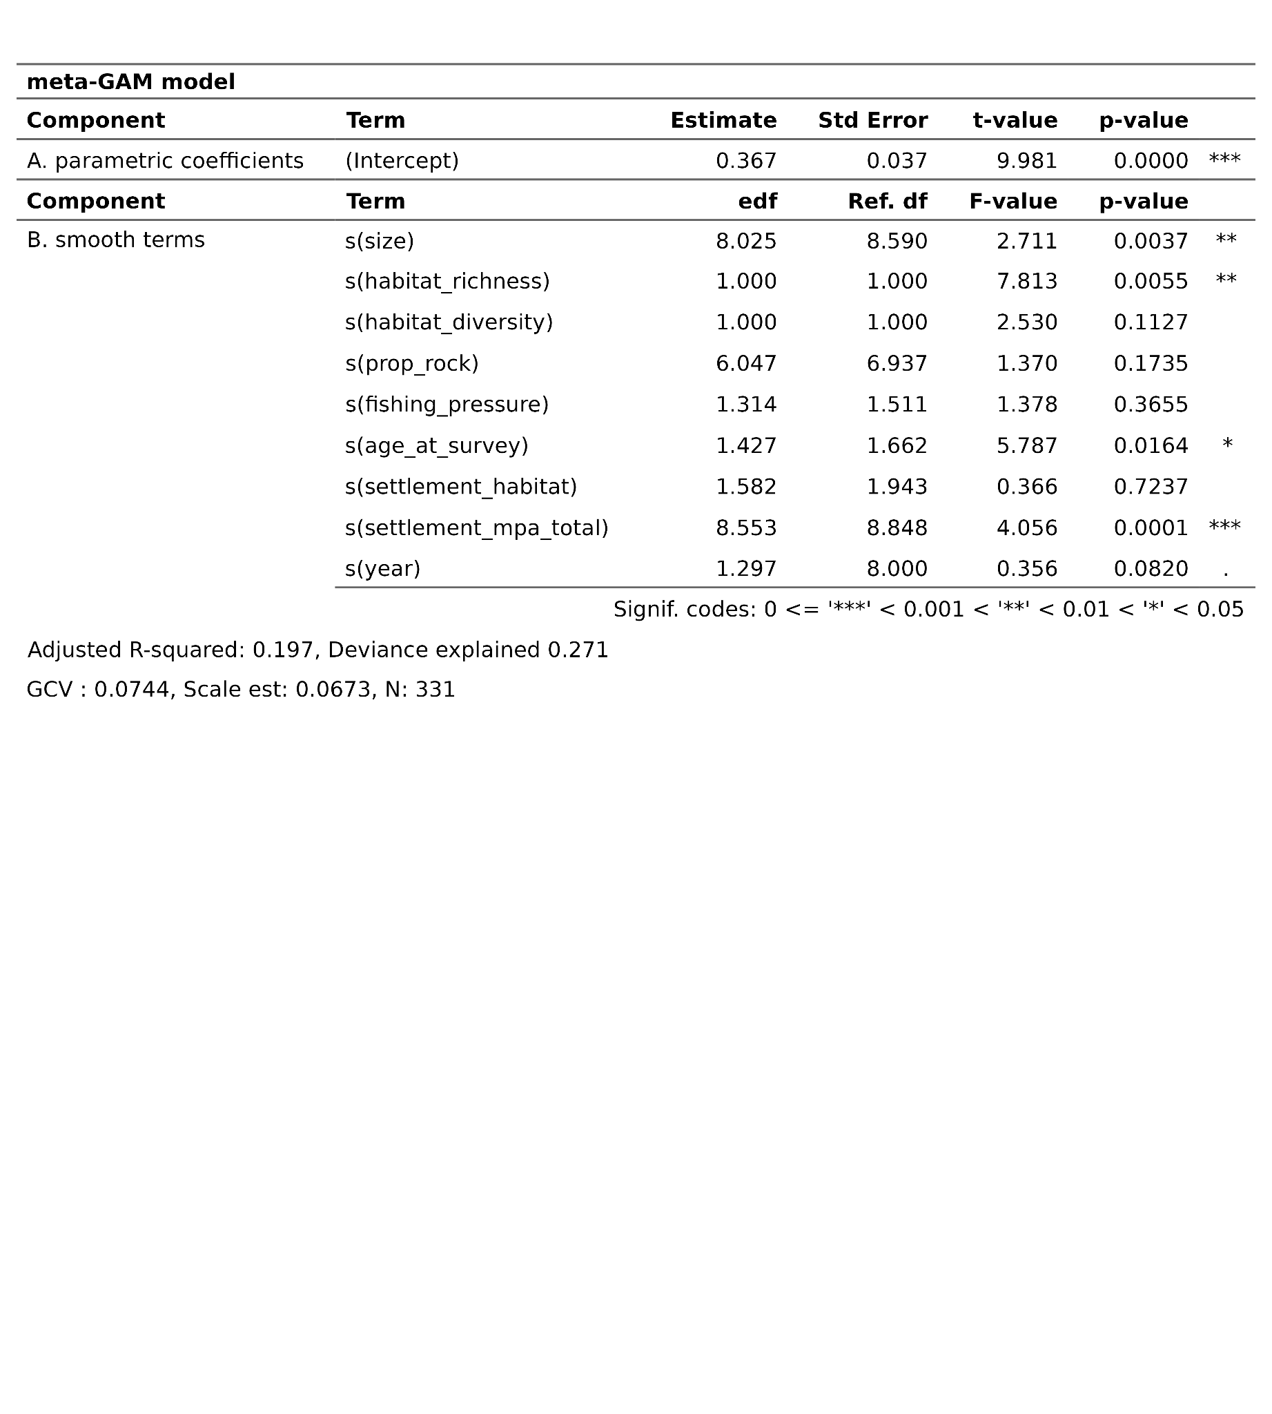

### 

### Supplementary Figures

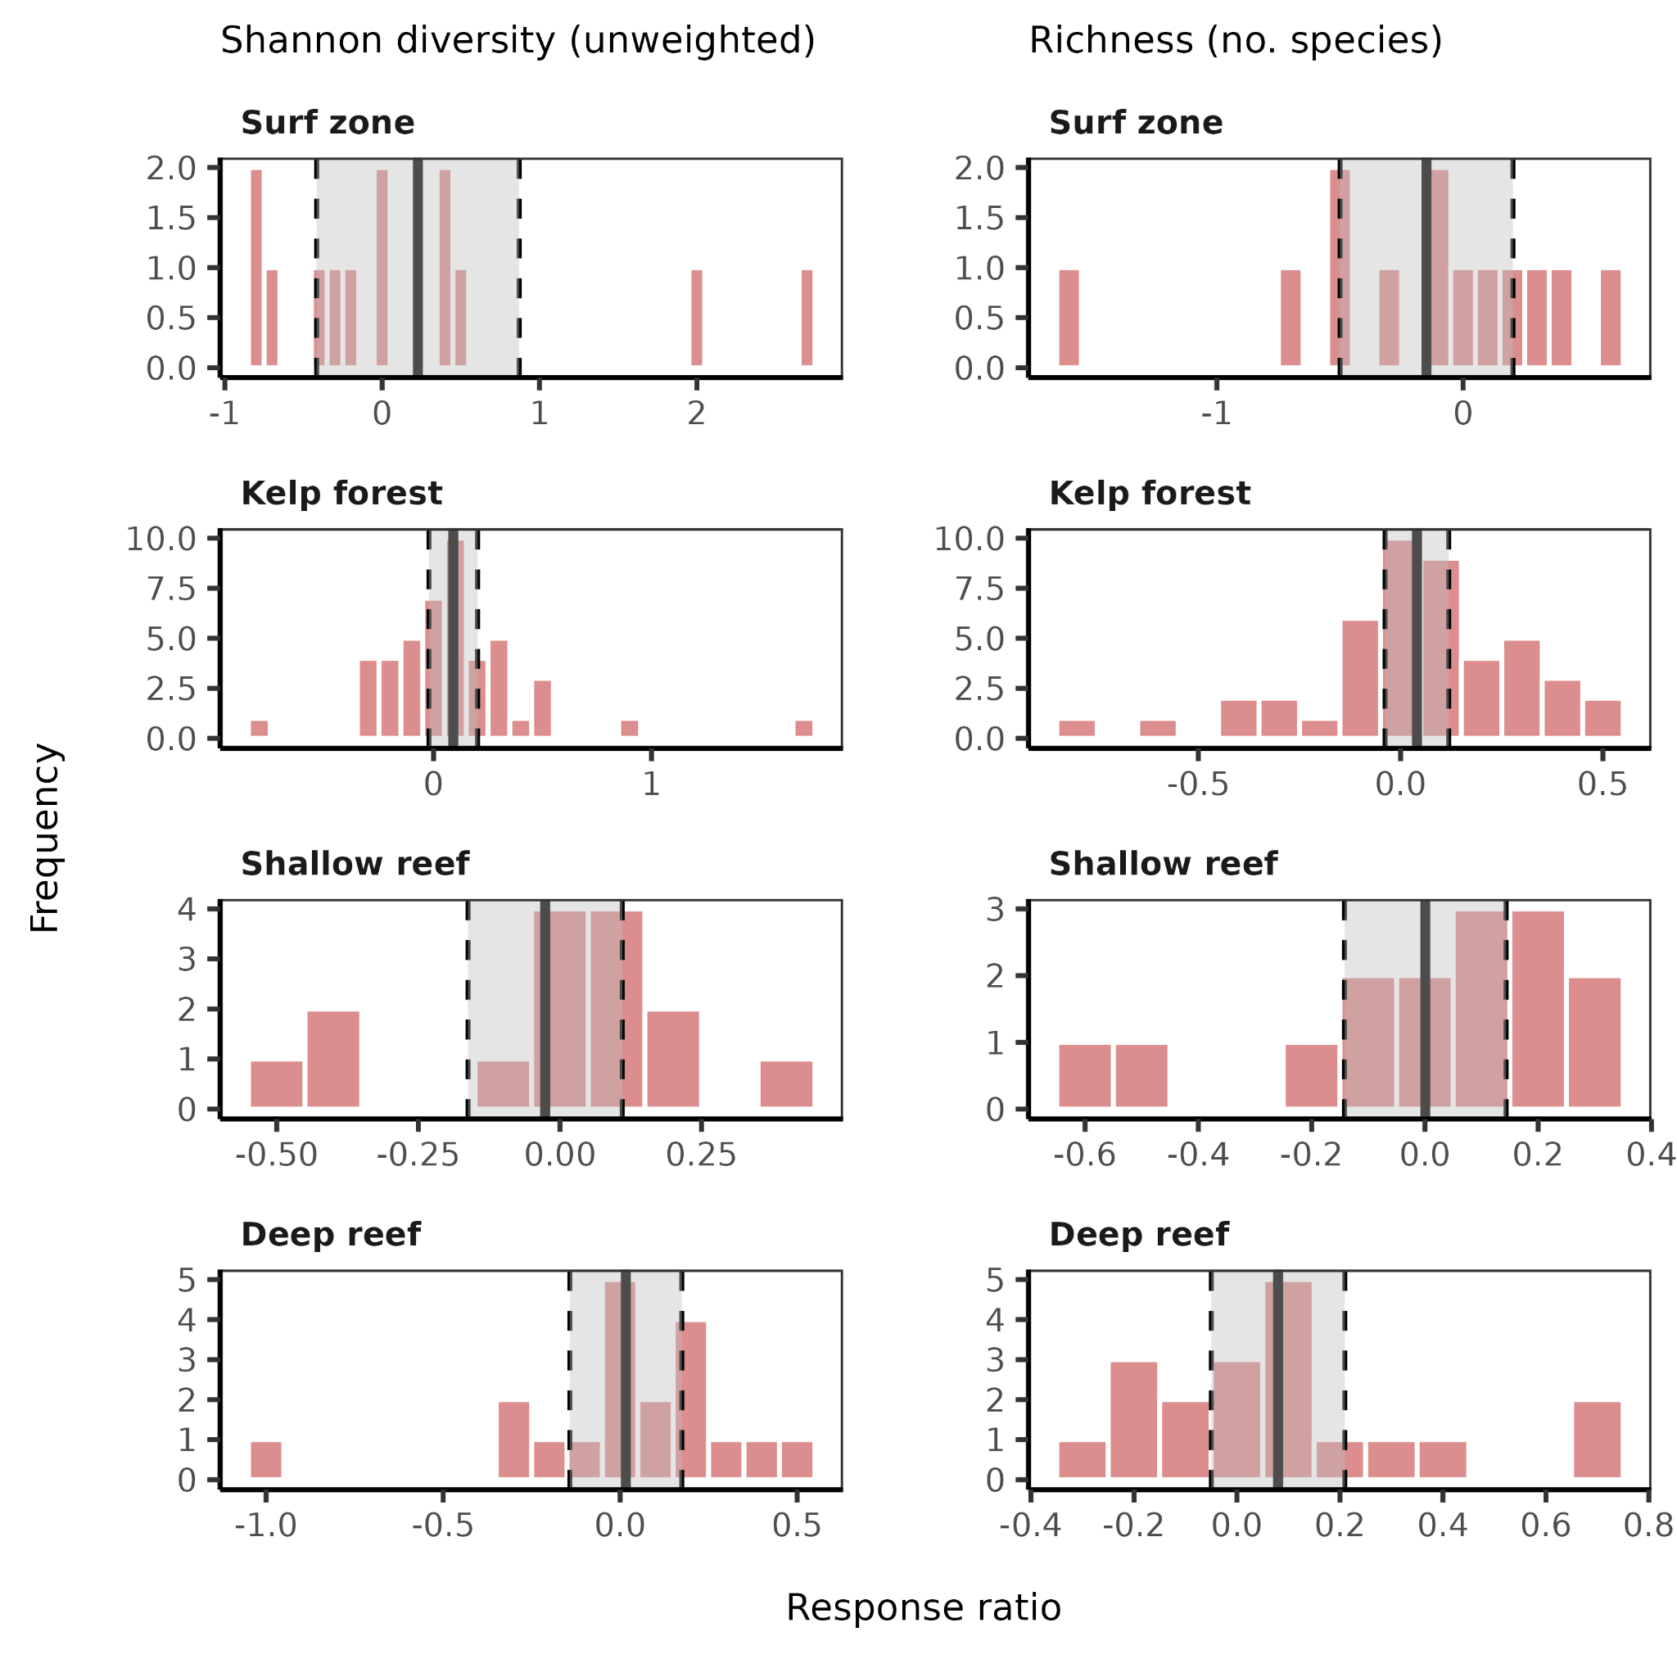

**Figure S1.** Shannon diversity (left) and richness (right) response ratios for four ecosystems (surf zone, kelp forest, shallow reef, deep reef). Each bar represents the response ratio frequency for the most recent year of sampling for each MPA. Solid vertical lines represent the mean response ratio, and the shaded areas indicate the 95% confidence interval. Confidence regions for all ecosystems overlap with 0, indicating that species diversity and richness are not significantly distinguishable between MPAs and areas that allow fishing.